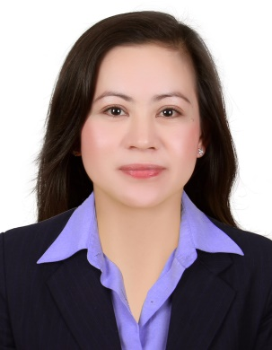
ROSALIE
ROSALIE.324202@2freemail.com

OBJECTIVE

To be part of an organization that offers a good opportunity for career growth and where my skills, experiences, knowledge and abilities can be further developed and effectively contribute towards the organization’s endeavors and the attainment of its goals and objectives.

QUALIFICATION

- Highly competitive, organized, disciplined and goal oriented.
- Outstanding communicative skills.
- Computer literate.
- Excellent physical and mental conditions.
- Responsible, friendly and hardworking.
- Career Eligibility Passer

WORKING EXPERIENCE

Dubai Mall, Dubai UAE
August 25, 2014 up to present

Sales executive

Job Responsibilities
- Greet customers as they arrive at the store and provide them with information about our items and/ or service.
- Direct customer by escorting them to packs and counters, suggesting items.
- Service customer by helping them to select the best items.
- Advises customers by providing information about our items.
- Organize and merchandise the display.
- Maintains items and sales inventory.
- Handle customer relations and complains.
- Participates in the strategic approaches to increase sales.

GALLERY BEAUTY SALOON
Hyatt Regency Hotel, The Galleria
Deira, Dubai, U.A.E
August 2010 to July 2014

Receptionist/Cashier
In-Charge

Job Responsibilities
- Handles incoming calls.
- Assist customers.
- Assist and handle management staff. Data entry, inventory of stocks and supplies.
- Promoting products to the customers.
- Prepares salaries and commissions to all staff.
- Over all in-charge.

ILOCOS TRAINING AND REGIONAL MEDICAL CENTER
Sevilla, San Fernando City of La Union
Telephone No.: (072) 242-1143
March 2007 to March 2010

Clerk/Data encoder
Job Responsibilities:
- Types reports, forms and specialized documents.
- Checks typed and other materials for accuracy, completeness, compliance with department policies and correct English usage, including grammar, punctuation and spelling.
- Maintains records and processes forms.
- Encode documents.
- Establishes and maintains office files, researches and compiles information.
- Reviews computer-produced reports for accuracy and makes corrections as a required, operates standard office equipments.

TRAINING EXPERIENCE

National Statistics Office (N.S.O.)
Main office, Sta. Mesa, Manila
December 1995 to March 1996

Civil Registrar Department
Job Responsibilities:

- Acts as receptionist, get the names and birthdates of the clients.
- Retrieve birth certificate.
- Provide a Xerox copy to the client with the attached signature of the record officer and the official seal.
- Release the documents.
- Keep files in order.

EDUCATIONAL BACKGROUND

Course : Bachelor in Computer Science
School : Arellano University
SY : 1992-1996

PERSONAL BACKGROUND

Birth Date : January 11. 1976
Birth Place : La Union, Philippines
Civil Status : Married
Language Spoken : English, Tagalog,
Visa Status : Transferable Visa

