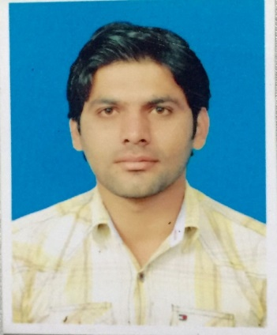
Name: Shah

Shah.324207@2freemail.com

Objective: | To join a reputed organization in order to provide innovative and quality work at challenging position to apply and utilize my skills as a great resource for the organization and for my professional career.

Academics: | Bachelor of Computer Science (Software System) ( 2012-2016)  Institution:  Federal University of Arts, Science & Technology , Islamabad  CGPA:  3.25/4.0  F.Sc (Pre-Engineering) 2010  Institution:  Divisional Public School & Collage Dera Gahzi Khan  B.I.S.E Dera Ghazi Khan  Marks:  753/1100

Semester Project: | - Online Distributor system  Develop as a final year project using asp.net, C#, Ajax as front end and Sql Server as back end.  - College Management System/ Hotel Management System  Developed as a semester project of the course Software Engineering using C# as front end and Oracle as back end

Professional Attributes: | - Excellent Analytical Skills  - Problem Identification  - Quick Learner  - Groomed Resource  - Outstanding Team player | - Self-Motivated  - Excellent Communication Skills

Special Skills: | - C#  - Asp.net  - OOP(java) ,C++  - Ajax Toolkit ,Crystal Report  - Oracle DBMS (9i,12c) & SQL Server 2008  - HTML , CSS, Bootstrap , JavaScript & Query String  - MS visual Studio, Sql Visual studio

Skill other than  Programing: | - MS Office , MS Visio, MS Project  - Software Installation/upgrade (Window ,Antivirus, Driver)  - Troubleshooting office network/printer/Scanner etc.  - Performing OS Optimization  - Photo Adobe Effect, Pro Show Gold  - 3d Max

Employment: | Dot Net Developer  Having One Year experience in IMIT(Information Technology)software House as junior dot net developer. Develop &maintain existing/new software.  Internee Software Developer  Having Three month experience in CDA as a internee software developer. Maintain the movement of file in CDA and other IT Task.

Interest: | I have keen interested in:
 | - Dot net  - IT Officer  - Software Development  - Web Development  - Software Testing | - Graphic Designing  - IT Asistant  - Reading Books  - Music & Movies

Personal Information: | Nationality  Visa Status  Visit Expiry  Religion  Date Of Birth  Marital Status | Pakistani  Visit Visa  20/01/2017  Islam  September 09,1992  Single

References: | Provided upon request

