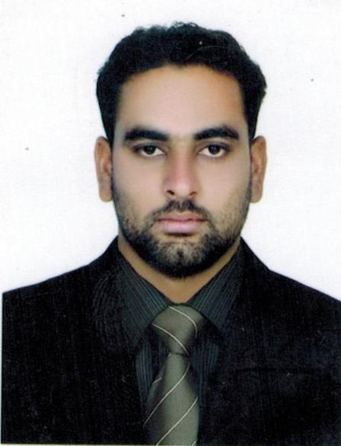CURRICULUM VITAE
Malik
Dubai – UAE
Email: malik.324276@2freemail.com
Post Applied Driver

Objective:-
A suitable position with an organization where I can utilize the best of my skill and abilities that fit to my education, skills and experience a place where an encourage and permitted to be an active participant as well vital contribute on development of the company

Educational Qualification:-

Academic : intermediate

Work Experience:-

  - Working with Joseph Industry's as a Driver from 09 Sep 2016 to till date.
  - Worked as a Security Officer in QBG Facilities management from 8 Sep 2012 to 21 May 2016.
  - Worked as a Brand Ambassador in Lakson Tobacco Company Pakistan 1 year.
Consecutive Job Responsibilities:-
- Handling driving job with full of responsibility and carefully.
- Sticking on time given by the transport in-charge
- Clearing document of consignment.
- Taking care of the goods handled
- Cleaning and keeping the vehicle tidy and sanitized
- Maintaining the log of periodical Maintenance schedule of Vehicle and taking to servicing garage on correct time as per schedule

Personal Information:-
Name : Malik
Nationality : Pakistani
Date of Birth : 10-01-1991
Gender : Male
Religion : Muslim
Marital Status : Married
Language Known : English, Hindi, Urdu

License Details:-
Date of Issue : 21-04-2016
Date of Expiry : 21-04-2026
Place of Issue : Dubai, UAE
Category : light Vehicle

