C-CURRICULUM V1TEA

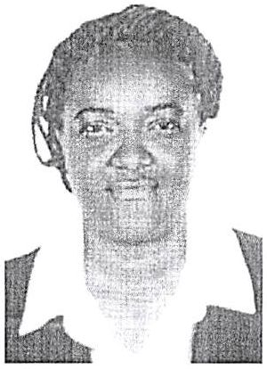

PERSONAL

Name: Esther

Nationality: Cameroon

Email: [esther.324730@2freemail.com](mailto:esther.324730@2freemail.com)

Gender: Female

Visas : long term visit visa

Marital Status: Single

POSITI ON: HOUSEKEEP1NG/CLEANER/STEWARDESS/KITCHEN

HELPER

CAREER OBJECTIVE

Seeking employment as a cleaner in a goal oriented establishment where I can contribute positively to its growth and development in a highly competitive business world

KEY SKILLS:

* Friendly, sociable and welcoming.

1 am calm, patient and polite, confident and self-motivated passionate to business Honest, reliable and hardworking team player

communicate well with people of all levels excellent time management skills PROFESSIONAL EXPERIENCE

CLEANING COMPAGNIE IN CAMEROON (Housekeeping Attendant) 2012-2016

RESPONSIBILITIES:

* Keeping all areas of the Home, including all toilets, clean and tidy.
* This includes washing, dusting, polishing, vacuum cleaning and sweeping as appropriate.
* Discussing with the guest rights and choices in relation to room cleaning.
* Ensuring that all cleaning equipment/materials are maintained in a safe, clean and efficient working condition.
* Where an item of equipment requires repair this should be reported to the manager.
* Ensuring that the manager is aware of the need for replacement materials and equipment for the satisfactory performance of the duties.
* Wear protective clothing in accordance with health and hygiene regulations and Infection Control guidelines
* Maintaining a friendly contact with users of the service respecting their right to choices, dignity, privacy and confidentiality at all times

CHATEAU HOTEL (DOUALA)

House Keeping Attendant

RESPONSIBILITIES:

* Cleaning of the guest rooms to standard as assigned
* Performing very physical labor
* Answering guest requests
* Providing excellent customer service as per the standards of the Hotel
* Courteously and promptly responds to guest room requests
* Investigates all guest inquiries in a timely fashion to provide the highest possible
* Performs side duties as required.
* Works closely with other departments to achieve maximum guest satisfaction
* Maintains a clean, safe, hazard-free work environment at all times
* Understands the emergency procedures for the entire Hotel.
* Answering guest requests when necessary.

COMPUTER SKILLS

* BASIC LANGUAGE SPEAKING
* FRENCH: WRITING AND SPEAKING
* ENGLISH: WRITING AND SPEAKING