Profile Summary
- (6+) years of experience in the health care industry.
- (4+) years of medical sales and customer development experiences in both pharmaceuticals and medical devices industries within multinational companies.
- (2) Years of experience in a community pharmacy chain as a senior and chief pharmacist.
- I hold a BSc. degree – Bachelor of Pharmacy and Biotechnology. I am registered with the Administration of Medical Licenses in the Ministry of Health in Egypt.
- Curious about Inventory Management and Customer Relationship Management.

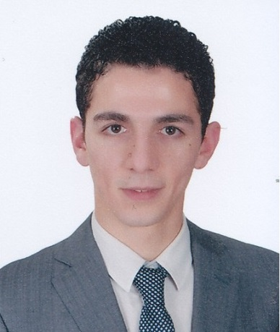
Yasser
Medical Sales Professional

Yasser.324889@2freemail.com
Professional Experience

Alumni Medical – Surgical Equipment Trading - UAE January 2016 to date
Medical Representative
Responsibilities:
- Sales representative responsible for the sales target in UAE starting with Abu Dhabi, Al Ain and Dubai.
- Leading the launch of the newly contracted companies in UAE: HarvestTech (Blood Components Processing), Demetech (Sutures), Equimedical (Hemostats), Locamed (Non-Invasive Surgeries) and others.
- Responsible for the negotiations with the Materials and Operations Managers along with providing medical and technical guidance to Orthopedic Surgery Departments, Operating Theaters and all of the Surgical Departments.
Achievements:
*** Three hospitals in Abu Dhabi are currently benefiting from Alumni pipelines of surgical devices.
- Delegated to be the warehouse manager in 2017.

Boehringer Ingelheim – Consumer Health Care (CHC) - Egypt March 2014 to October 2015
Medical Representative
Responsibilities:
- Sales Representative responsible for (Nasr City) as the most potential area in Cairo, Egypt
- Conducting the launch of (Pharmaton Vitality), a multivitamin and tonic.
- Performing different sales and merchandising activities to promote for the whole CHC Classic Line portfolio including: Buscopan, Bisolvon and Mucosolvan.
Achievements:
*** Performed a rocket launch and achieved the highest national sales growth rate in Pharmaton Vitality.

Covidien – Autosuture - Egypt May 2012 to November 2013
Product Specialist
Responsibilities:
- Product Specialist in Autosuture - The Endovascular Business Unit.
- Promoting surgical staplers to surgeons and providing the technical guidance needed at the operating theatre.
- I was assigned to the National Cancer Institute (NCI) in Cairo University Hospital which was the account of the biggest tender and the highest net worth in the company after achieving success with potential customers.

Achievements:
*** I succeeded in outperforming the main competitor with the most potential accounts within the industry.
- El Sheikh Zayed Specialized Hospital: Outplaced the competitor by offering the right proposal to the purchase department and building trust with the Surgery Department.
- Dar Al Fouad: 300% growth in 2012 year to date sales in one account from 20K Egyptian Pound to 60K EGP.

Faten Pharmacies – Egypt July 2010 to May 2012
Chief Pharmacist
Responsibilities:
- Dispensing prescriptions, counseling patients and giving over the counter product advice for twenty two months.
- We were able to be the second best-selling pharmacy and the most successful compared to assets and expenses in Al Rehab City – Cairo, as we relied only on the customer relations rather than advertisements.
- I managed the pharmacy of the highest spirit in one of the highest-level societies in Egypt.

Academic Degree - Egypt
Bachelor of Science in Pharmacy and Biotechnology from the German University in Cairo, Class 2010.
Cumulative GPA: B = (2.06 German system)

Public Presentations and Undergraduate Activities
- 2007-2010: GUC-SPSA (Scientific Pharmaceutical Students Association) fund raiser, we were able to organize the first WHO model in Egypt and second in the world it was an academic simulation of the United Nation's special agency: the World Health Organization. The GUC-SPSA has affiliations with a number of national and international organizations. The SPSA is a member of the EPSF the Egyptian Pharmaceutical Students Federation, and a Member in Association in the IPSF the International Pharmaceutical Students Federation.

- 2009: RTC (Recruitment and Training Committee) in Cairo University, faculty of pharmacy as a delegate in the course of Project Management about the first awareness campaign model where we got sponsored in the first phase so that our proposed HCV (Hepatitis C Virus) campaign could be applied.

- 2009: Attended many presentations in medical marketing and experienced the career of medical representatives as a summer trainee in AstraZeneca for two months in Al Kasr Al Ainy hospital in which several meetings were held with different departments.

- 2009: AMP ( PEPSI energy drink) marketing campaign, at the Global Conference on Business Transaction (GCBT), awarded a certificate of distinction from the Marketing and Sales Council for being a member of the team winning the 2nd place and best movie advertisement.

- Head of fundraising in GCBT 2010 - first students run activity in the GUC- where I was able to interact and accomplish several marketing needs while such activity will always be a shining and recommended experience for people to get involved. I enjoyed attending and organizing university conferences in business and healthcare, as well as recruiting the applicants from different universities by motivating them to participate in business simulation councils. I had created unique marketing solutions for the cause of making the GUC-GCBT the hugest conference in terms of applicants’ intensity, delegates and sponsorship mutual benefits and opportunities in the history of our university.

Key Competencies

- Medical devices and supplies.
- Bidding and tendering
- Closing Deals
- Pharmaceutical industry
- Consumer goods
- Merchandising
- Inventory Management
- Customer Relationship
- New Business Ideas

Thank you

