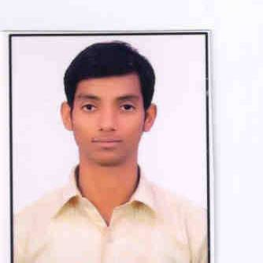
CURRICULUM –VITAE

Sajjad

Email ID : sajjad.325164@2freemail.com
Visa Status : Employment Visa

CAREER OBJECTIVE

In search of a challenging position of civil engineering where I can work with diversified and creative projects with a progressive and dynamic organization providing a mutually beneficial environment so that to make me efficient and productive.

PROFESSIONAL QUALIFICATION:

➢ Diploma in Civil Engineering from F/O Baba Saheb Ambedkar Polytechnic affiliated to
The Institution of Civil Engineers (India)
➢ successfully completed Diploma in June 2014
➢Summer training from JAYPEE Associates as trainee Engineer from May-2013 to Nov 2013 (Real estate Building)
Summary of Experience& responsibility: I have total 2 years 8 months experience as
Given–

➢Currently working as civil site engineer with (sub contractor) BIN SAIFAN BLD CONS CONT L L C(Etisalat network) from 1st Nov 2016 to till date.
➢Six months working experience as civil site engineer with (contractor) MEENA COSTRUCTIONS AND INTERIORS PVT LTD (private residential villa) from 4th Apr to 4th Oct 2016 .
➢One year one month working experience as civil site engineer with (consultant) ELEGANT DESIGN SOLUTIONS PVT LTD (private residential villa) from26th Nov 2014 to 26th Dec 2015 .
➢One year one month working experience as Junior Engineer with (contractor)Bhyana Builders Pvt Ltd (high rise building) from 22thOct 2013 to 20th Nov.2014 in Delhi.

➢ Preparation of D.P.R (Daily Progress Report) and D.L.R (Daily Labor Report)
➢ checking of columns, beam and slabs dimensions & reinforcement.
➢Familiar with the checklist of cement, sand, bricks, concrete etc.
➢Reading of site drawing as schematic & Working Drawing
➢Estimation of quantities of concrete and steel and preparing the sub-contractor bill also.
➢Good coordination with foremen, labor Sub-contractor, suppliers, consultants, client and our superiors as well as.
➢seen other activities like rock anchorage, water proofing, and brick work of superstructure. .
➢Execution of Pile foundation work.
➢Preparation of Daily Progress Report.
➢Execution of Site work.
➢Supervision of all actual activities at site.
➢ scheduling of manpower, material, equipment & activities for actual daily needs on
Construction sites.

Academic Qualification
➢ 10th passed from B.S.E.B. Board
Technical Skills:

➢ MS office (Word, Power point, Excel)
➢ Auto cad
➢ Working experience in Windows ( XP, Vista, 7)

Personnel Details:

➢ Marital Status: Unmarried
➢ Date of Birth: 01/04/ 1994
➢ Sex: Male
➢ Nationality: Indian
➢ Language Known: English, Hindi
➢ Driving License: Valid (Indian)
➢ Passport: Valid (Indian)

Declaration
I believe & have confident that I exhibit maturity, and stability, and I am eager to make a positive contribution for the parallel growth of your organization & my own career graph.

I hereby declare that the above mentioned information is correct to the best of my knowledge and I bear the responsibility for the correctness of the above mentioned particulars.

