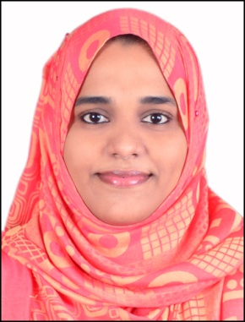
Dr.FATHIMA
Bachelor of Dental Surgery, BDS.
FATHIMA.325201@2freemail.com

Career Objective

A confident healthcare professional who can successfully diagnose and treat patients' dental conditions. Able to work as a part of the dental team, and has a flexible approach to work. Looking for a General Dentist opportunity to work in a reputable hospital and utilize my professional skills to improve client satisfaction for the benefit of the organization.

ELIGIBILITY CRITERIA

Ministry Of Health (MOH) (2016) Certificate No:-147758

PROFESSIONAL EXPERIENCE

- Working as a GP DENTIST in Naseem Al Manama Specialized center, Al dhaid.
- Worked as Dental Surgeon in DENTA ORO DENTOFACIAL CARE, HARIPAD for two Years (April 2013-April 2015).
- One year internship in RAJAS DENTAL COLLEGE, THIRUNALVELI

Duties:
- Providing professional dental service and care to patients.
- Examining patient’s teeth and diagnosing their dental conditions.
- Dealing with routine appointments and checkups, taking impressions etc.
- Dealing with emergency cases like relieving a patient’s pain.
- Excellent in work like filling cavities, Scaling, RCT, repairing fractured teeth and Extraction.
- Performing corrective surgery to extract teeth and replace missing teeth.
- Updating a patient’s medical records.
- Diagnosing & treating conditions such as decaying teeth and gum disease.
- Reassuring anxious patients and clearly explaining procedures to them.

Key skills and Competencies

- Experience of advising patients on diet, brushing & other aspects of dental care.
- Keeping up to date with the latest developments in dentistry.
- Excellent listening, communication and interpersonal skills.
- Able to write prescriptions for antibiotics and other dental medication.
ACADEMIC PROFILE
BDS with First Class from The Tamil Nadu Dr. M.G.R. Medical University, Tamil Nadu (2012).
Higher Secondary with 75 % marks in science from Bishopmoore Vidhyapith, Mavelikkara (2006)
SSLC with 60% from RVSM Higher Secondary School, Prayar (2004) .

STRENGTHS
- Sincere and hard working.
- Highly motivated and willing to learn.
- Ability to work under pressure.
- Confident and Hardworking
- Computer Skills ( MS office and Normal Operations)

PERSONAL DATA

Date of Birth | 03/05/1988
Sex | Female
Nationality  Religion | Indian  Muslim
Marital Status | Married
Languages | English, Malayalam, Tamil
Interests | Music, Travelling, Reading, etc...
Address (India) | Panackavadakkathil house, Memana,  Oachira PO, Kerala - 690526, India.

REFERENCE

Reference will be provided upon request.

The above mentioned details are accurate to the best of my knowledge.

