RanaAdel
RanaAdel.325332@2freemail.com 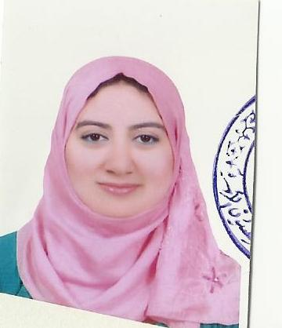
Objective
Position as an English teacher
Certifications
- Seminar in teaching soft skills
- ICDL certificate
- IELTS band 6
Experience
- worked as an English teacher at alnashaaelsaleh private school.
- Worked before as an instructor English –translator,sept.2008,nov,2009.
- Worked before at noran language institute,almutared
- Providing a stimulating learning environment for Grammar classes in which students can develop their grammatical skills to their full potential
English Teacher, nov,2008 – jul. 2009
British institution for languages and computer-BILC-dameitta,EGYPT.
- Utilized computer-assisted educational resources to promote English Grammar and Composition writing skills to 12th graders
- Prepared, facilitated, and implemented remedial programs for Adult students requiring extra help
- Evaluated and communicated progress made by students, and networked with other professionals to discuss students needs on individual basis
- Wrote and taught dynamic lesson plans
- Teaching soft skills(how to control your body language , and prepare your presentations effectively)
- Written translator –all kinds of written translation

Key Competencies
- A talent for involving and inspiring students of all ability levels
- Ability to effectively establish rapport with students from diverse cultural backgrounds and to tailor English teaching methods to suit their individual needs
- Excellent written and verbal communication abilities, with tested skills of conveying the subject material in an accessible and inductive manner
- Highly developed computer skills, with comprehensive experience of exploiting technology in the classroom to make the most of the learning experience

Relevant Interests
Speech & Debate, Essay Writing, Theatre,. An opportunity to coach extracurricular activities is most welcome.
Education
B.A., English and Literature, 2007
Ain Shams University,The faculty of Al ALsun

