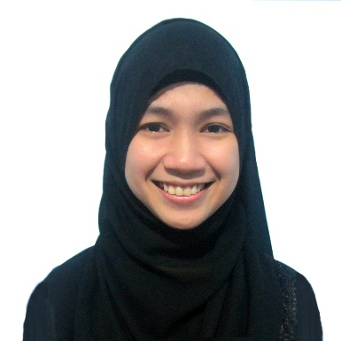
ALIFA , CPA, MICB
ALIFA.325338@2freemail.com

OBJECTIVE

- To utilize my knowledge and skills in the best probable way to grow my career beyond my limits.

EDUCATION

Eligibility: Member of Institute of Certified Bookkeepers (MICB)
March 2016 to present
National Institute of Accounting Technician
Iligan City, Philippines

Eligibility: Certified Public Accountant (Licensed)
October 2015 to present
Professional Regulation Commission
Cagayan De Oro City, Philippines

Tertiary Bachelor of Science in Accountancy
Mindanao State University - Main
College of Business Administration and Accountancy
Marawi City, Philippines
April 14, 2015
Department Service Awardee

Secondary Mindanao State University
Institute of Science Education - Science High School
Marawi City, Philippines
March 27, 2010

Elementary Marawi Central Elementary Pilot School (MCEPS)
Marawi City, Philippines
March 24, 2006
Valedictorian

SKILLS

- Good in oral and written communications in English language
- Expert in Microsoft Office (Word, Excel, and PowerPoint)
- Excellent Accounting Knowledge
- Ability to Analyze Quantitative Data
- Proactive Problem Solver
- Good team player
- Fast learner
- Ability to work under pressure
- Sound knowledge in accounting software such as Quickbooks, Peachtree, and Tally.

WORK EXPERIENCE

Santos Cua Accounting, Auditing and Consulting Firm
2F Ruby Bldg., Tiano-Mabini St., Cagayan de Oro City
On-the-Job Trainee
November 7, 2015 – April 28, 2016

Duties and Responsibilities:
- Reviewed and scrutinized various financial statements as first line reviewer
- Prepared unaccompanied the financial statement of a client
- Participated in preparing a feasibility study for a hotel and casino business venture
- Helped in preparing tax returns
- Participated in field works and performed internal audit
- Assisted senior auditor in all phases of external and internal audit
- Reviewed notes to FS if they conform with IFRS requirements
- Reviewed petty cash disbursement vouchers
- Prepared a summary of daily sales and daily purchases of a client

ACHIEVEMENTS/AWARDS RECEIVED

Department Service Awardee
50th Commencement Exercises (SY 2014-2015)
Mindanao State University – Main Campus
Marawi City, Philippines

1st Placer in Cup 2
Practical Accounting II and Management Advisory Services
23rd Annual Regional Convention
Cagayan de Oro City, Philippines

1st Placer in Cup 5
All Board Subjects
23rd Annual Regional Convention
Cagayan de Oro City, Philippines

1st Placer in Cup 3
Audit Theory
13th Regional Midyear Convention
Cagayan de Oro City, Philippines

1st Placer in Cup 2
Management Advisory Services
Accountancy Week 2014
Academic Complex, College of Law, MSU, Marawi City, Philippines

Commendation for Academic Excellence
Dean’s Honors Lister
2011 Crème de la Crème
Dimaporo Gymnasium, MSU, Marawi City, Philippines

AFFILIATIONS

Member
Philippine Association of Islamic Accountants (PAIA)
July 2016 to present

Member
Philippine Institute of Certified Public Accountants (PICPA)
December 2015 to present

Vice President for Audit
Junior Philippine Institute of Accountants (JPIA), MSU Main Local Chapter
School Year 2013 – 2014

SEMINARS ATTENDED

Introduction to Benchmarking
Institute of Management Accountants (IMA)
Hilton Hotel, Doha, Qatar
November 26, 2016

Advanced Excel Training
Philippine Institute of Certified Public Accountants (Qatar Chapter)
La Cigale Hotel, Doha, Qatar
November 16, 2016

Joint Induction and Launching
Philippine Association of Islamic Accountants
Mallberry Suites, Cagayan de Oro City, Philippines
July 17, 2016

Seminar/Workshop on Zakat and Awqaf
Philippine Association of Islamic Accountants
Mallberry Suites, Cagayan de Oro City, Philippines
July 15-16, 2016

