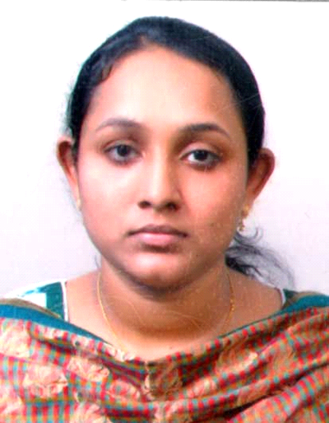
FOR A CAREER IN SPEECH LANGUAGE PATHOLOGY/ AUDIOLOGY

To be associated with a dynamic and growth-oriented institution which would give me ample scope to work passionately in the field of my choice and also to apply my skill sets for the organization’s growth.

Academic Qualification
Qualification | Year of passing | Institution | Board/University
Bachelors in Audiology and Speech-Language Pathology with 10 months internship | 2010 | Aarupadai veedu medical college, (AVMC) Pondicherry | vinayaka mission university
12th Standard | 2006 | Sharada vilasam higher secondary school | Kerala University
10th Standard | 2003 | Jyothi nilayam English medium high school | Kerala University

Work Experience in the Concerned Field:
Working as audiologist and speech language pathologist in sound plus hearing care centre and sound plus school for the differently abled children since October 2010 to present.
Duties and Responsibilities
- Administration and interpretation of pure tone, speech tests and immitance audiometry

- Selection, fitting and prescription of hearing aids and Trouble shooting of hearing aids

- Report writing and organization of screening and diagnostic camps

- Counselling
- To Assess, Diagnose and Intervene children and Adults with Speech and language problems such as mental retardation, Cerebral palsy , Autism spectrum disorders, Attention deficit hyperactivity disorder , Hearing impaired, voice, fluency articulation, phonological and neurological disorders for their communication functions and guide teachers and family to enhance on their positive aspects

- Counseling parents of children with special needs for adequate speech stimulation and promote positive attitudes

As part of BASLP Internship in AVMC, Pondicherry
CENTER NAME | EXPERIENCE
National Institute For Empowerment of Persons with Multiple Disabilities( Muttukadu, Tamilnadu,India ) | 2 months
Mylai Hearing Aid Centre ( Mylapore, Tamilnadu, India | 2 months
Samvaad Institute of Speech and Hearing ( Hebbal, Bangalore, India) | 1 month

SEMINARS , WORKSHOPS AND CONFERENCES ATTENDED

- Participated in various National and International seminars and conferences on Cleft lip and Palate, Dysphagia, Alternative and Augmentative communication, Down’s syndrome, International symposium for Audiological medicine and other conferences and workshops related to Audiology and Speech-Language Pathology

- Conducted different screening and awareness camps in schools and public for assessing speech language and Audiology related disorders

Registration Details:
Licensed by Rehabilitation council of India (RCI)
KEY AREAS OF INTERESTS
- Childhood Speech and Language disorders
- Aural Rehabilitation
Personal Profile:
Date of birth : 21 June 1987
Sex : Female
Religion : Muslim
Nationality : Indian
Marital Status : Married
Linguistic Proficiency : Malayalam (mother tongue), English, Tamil

DECLARATION
I here by declare that the above mentioned information are true and best of my knowledge and belief.

