Rohit
Rohit.325481@2freemail.com

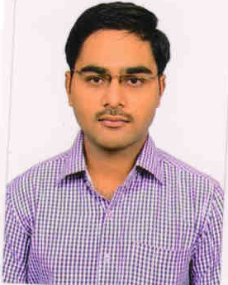  Personal Details  DOB : 06-02-1991  Status: Single  Date of issue:  08/08/2012  Date of Expiry:  07/08/2022  Nationality : Indian  Visa: visit visa  Address  Post Box No: 7216  , Dubai - UAE  Strengths  - Ability, Interest and willingness to learn.  - Excellent Communication Skill.  - Adaptability to Change.  - Ability to work in shift.  - Great team worker, diligent and honest. | APPLICATION FOR THE POST OF PHARMACIST  Abridge  Seeking a challenging and responsible position in Pharmaceutical field and to utilize my skill and experience towards professional growth and development in a renowned organization as well as, helping me advance in my career. To use my talent and skills to serve mankind and to create a better tomorrow.  WORK EXPERIENCE  WORKED AS DHA PHARMACIST IN LIFE HEALTH CARE GROUP FROM 21 -08-2014 TO 18-08-2016.  WORK AS PHARMACIST IN SRI GALAXY PHARMACY 28-05- 2012 TO30-05- 2014.  DUTIES AND RESPONSIBILITES  - Supply medication to the customers according to the prescription by the doctor  - Explain the dosages and side effects to the patients regarding the medications  - Educating the patient on the combination of different medications  - Staying updated on the latest drugs in the market  - Keeping a watch over the drugs nearing expiry  - Excellent customer care  - Extensive knowledge of medications and medical terminologies  - Broad understanding of all areas of pharmaceutical operations  - Excellent interpersonal skills  - Data entry and good computer knowledge.  - Stock maintenance and expiry management.  - Maintaining customer relationship keeping focus on business enhancement.  Job Profile  A challenging career in a business system that encourages continuous learning and creativity. To work in a more challenging environment in order to develop effective communication, technical knowledge, leadership qualities, self motivation and  motivating others being a team player, self confidence and multi tasking.  ACADAMIC QUALIFICATIONS  BACHELOR OF PHARMACY (2008-2012) HIGHER SECONDERY SCHOOL (2006-2008) SECONDERY SHOOL (2005-2006) Seven hills college of pharmacy, TIRUPATHI, A.P.INDIA (72%) Ranganadha junior college, TIRUPATHI ,A.P INDIA (89%) Rami reddy rayalseema high school, TIRUPATHI,A.P, INDIA (80%)  computer knowledge  Windows  MS OFFICE  WEB BROWSING  LANGUAGES KNOWN  English, Hindi, Telugu .  Declaration.  I hereby declare that the above information given by me is true to the best of my knowledge and belief. I assure you that I will be a successfully person in your concern by fulfilling my duties and responsibilities.  Date: Yours Faithfully,  Place: Dubai ROHIT

