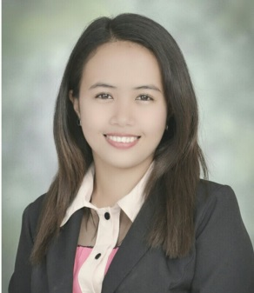
ROSSELE
E-mail Address: rossele.325558@2freemail.com

OBJECTIVE
To work extensively with a company that is capable of developing my skills and potentials while applying acquired knowledge to contribute for the advancement of the company.

PERSONAL INFORMATION

Date of Birth : October 4, 1993
Place of Birth : Agoo, La Union, Philippines
Civil Status : Single
Height : 5’2”
Weight : 45 Kgs.
Religion : Roman Catholic
Language Spoken : English, Tagalog

Skills : Marketing Skills, Computer Literate,
Flexible, Adaptable, Good team member, Efficiency in learning new things,Superb customer relation skills, quality assurance & control
Good communication skill,Good in Micros

EDUCATIONAL ATTAINMENT

College : Don Mariano Marcos Memorial State University
Mid La Union Campus, San Fernando City, Philippines BACHELOR OF SCIENCE IN BUSINESS ADMINISTRATION
MAJOR IN MARKETING
Year : SY 2010-2014

Secondary : San Gregorio National High School
- San Gregorio Caba, La Union, Philippines
Year : SY 2006 – 2010

Primary : San Cornelio Elementary School
San Cornelio, Caba, La Union, Philippines
Year : SY 2000 - 2006

WORKING EXPERIENCE

Company : Novotel Ibis Abu Dhabi Gate Hotel
Position : Spa Receptionist
Year : February 17, 2015 to Present

TRAININGS AND SEMINARS

Career and Employment Coaching 2013
DMMMSU-MLUC, City of San Fernando, La Union
October 1-2, 2013

Productivity and Quality Management
Saint Louis College, City of San Fernando, La Union
September 14, 2013

Strategic Marketing Conference for Students
Cuneta Astrodome, Pasay City
July 25, 2013

Professional Salesmanship
DMMMSU-MLUC, City of San Fernando, La Union
March 1, 2013

Strategic Marketing Conference for Students
Mall of Asia, Arena, Pasay City
July 31, 2012

Time and Stress Management Seminar
DMMMSU-MLUC, City of San Fernando, La Union
March 7, 2012

Adobe Photoshop Workshop Seminar
DMMMSU-MLUC, City of San Fernando, La Union
February 21, 2011

____________________________
Applicant’s Signature

