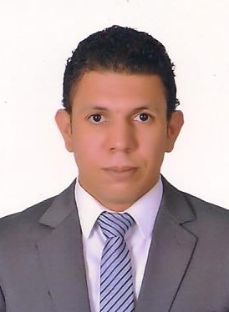
Mohamed
Mohamed.325870@2freemail.com

objective

Seeking a sales associate position with your company to contribute people skills
sales expertise, problem solving skills, and customer relationship management.

EDUCATION

2003 – 2008 BACHELOR OF social service – Faculty of Social service from
Sohag University

Work Experince

Position : Assistant store Manager

Employer : Vodafone Egypt

Period : Nov 2013 till Nov 2016

Responsibilities : •Manage the store sales team to ensure customers are being helped in a timely
• Conduct sales and inventory management
• Assist in employee recruiting, training and development
• Manage net revenue at store level
• Inspire and encourage employees to ensure high level of morale
• Assist customers and troubleshoot customer service issues when necessary

Position : Salesman

Employer : Royalceramic in Dubai

Period : Nov 2012 till Aug 2013

Responsibilities : •Greet customers when they arrive at the store and ask if they need assistance
•Process sales transactions at the POS (point-of-sale) counter
• Suggest upsell items to customers based on the items they have chosen
• Execute special orders for items that are not in stock or that we do not carry
• Call other stores when necessary to find items in stock
• Replace merchandise on the shelves, paying special attention to end caps
• Arrange special sale and clearance items at the front of the store for maximum
visibility
• Build rapport with customers and provide them with genuine guidance and
support
• Train new sales staff as needed by management

Position : salesman

Employer : Vodafone Egypt

Period : Jun 2009 till Jul 2012

Responsibilities : • Welcomes customers by greeting them; offering them assistance.
• Directs customers by escorting them to racks and counters; suggesting items.
• Advises customers by providing information on products.
• Helps customer make selections by building customer confidence; offering
suggestions and opinions.
• Documents sale by creating or updating customer profile records.
• Processes payments by totaling purchases; processing checks, cash, and store or
other credit cards.

trainings& courses

May 2011 Attended Sales, Marketing and Customer Service Training Course

skills

Language:

Arabic :Mother tongue.
English:(Reading, Writing, Speaking and Understanding) is very good.

Computer:

Certifications & Traning

Microsoft Certified Professional (MCP)
Microsoft Office Spcialist (MOS)
Attended For MCSE 2003 in Microsoft Partners
Attended For A+ software&hardware from Comptia
Skills
Very good Oracle system
Excellent knowledge of Win, Word, Power Point & Excel.
Very good knowledge of Internet Browser & Outlook

personal characters

- Active, Hard worker and dependable.
- Highly dynamic and self motivated.
- Ambitious, creative and well oriented.
- Able to work under stress conditions.

personal interests

Reading – Social media - Foot ball – Beliardo

refrences

All certificates and references are available upon request.

