Contact HR Consultant for CV No: 325888
E-mail: response@gulfjobseekers.com
Website: http://www.gulfjobseeker.com/employer/cvdatabasepaid.php

RER OBJECTIVE
- To work hard with full determination and dedication to achieve organizational as well as personal goals.

- To work in a challenging environment that provides genius opportunities for learning
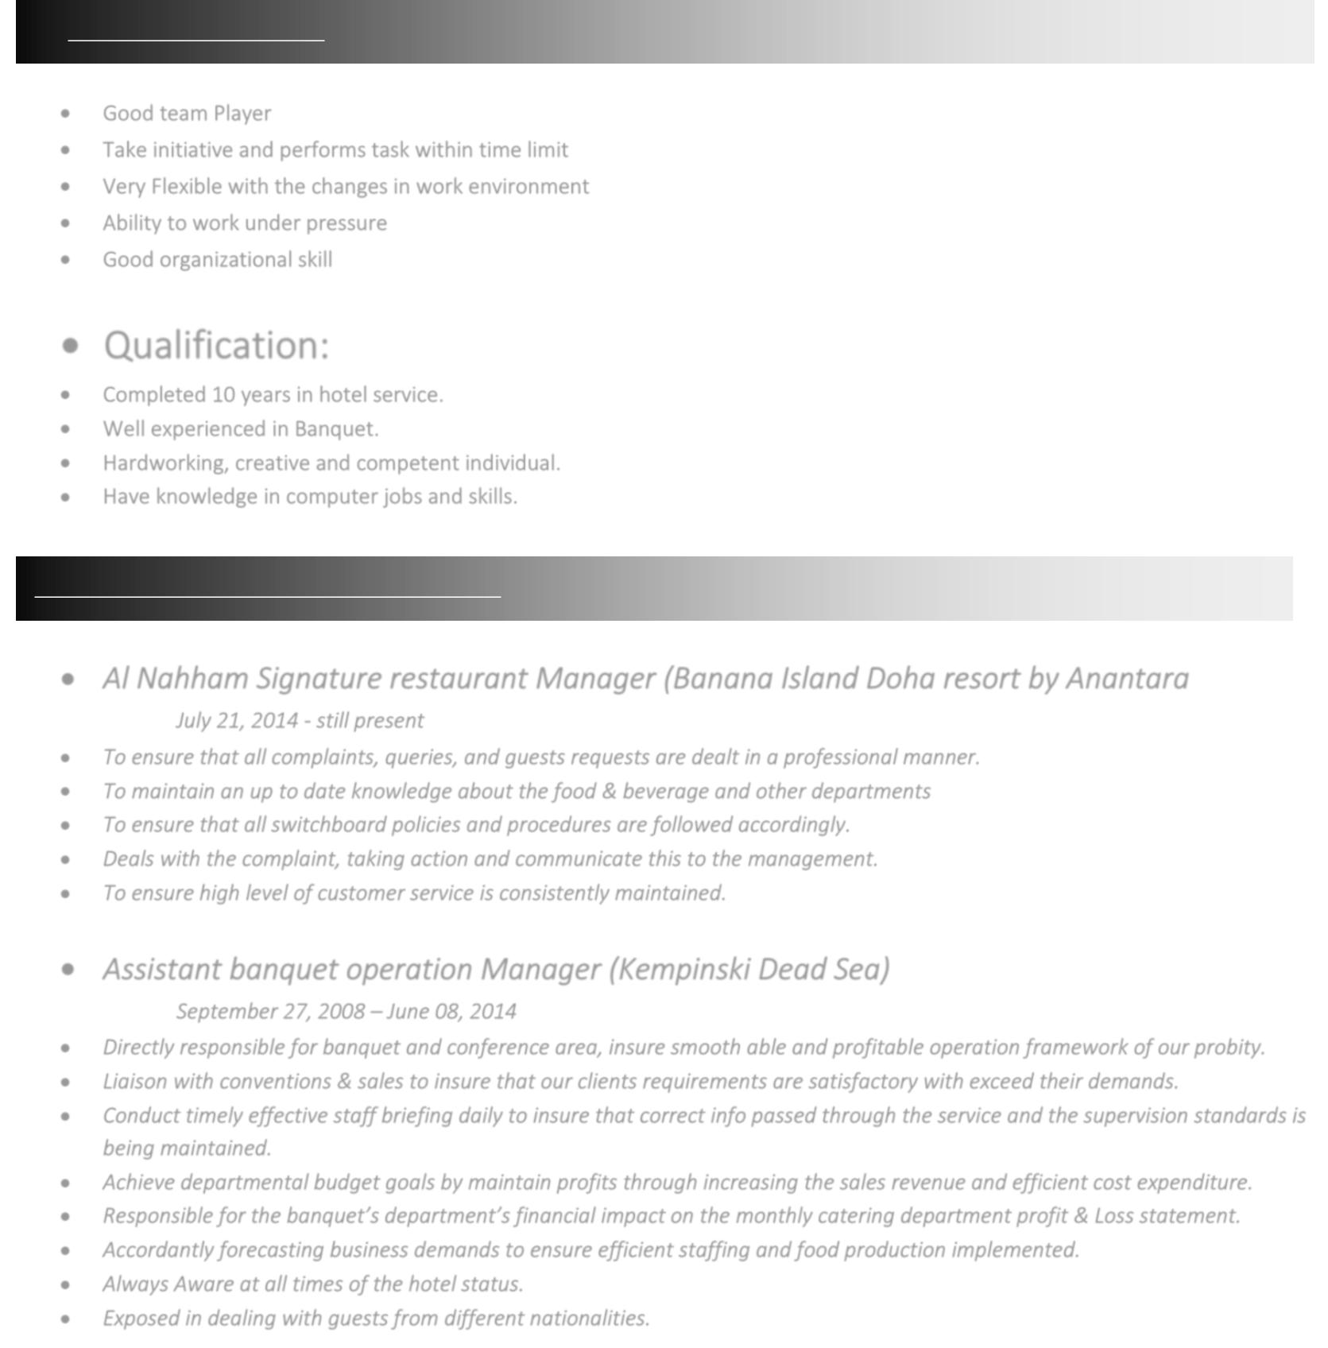
CORE COMPETENCIES:

- Good team Player

- Take initiative and performs task within time limit

- Very Flexible with the changes in work environment

- Ability to work under pressure

- Good organizational skill

- Qualification:

- Completed 10 years in hotel service.

- Well experienced in Banquet.

- Hardworking, creative and competent individual.

- Have knowledge in computer jobs and skills.

WORK EXPERIENCE AND DESCRIPTION:

• Al Nahham Signature restaurant Manager (Banana Island Doha resort by Anantara

July 21, 2014 - still present

- To ensure that all complaints, queries, and guests requests are dealt in a professional manner.

- To maintain an up to date knowledge about the food & beverage and other departments

- To ensure that all switchboard policies and procedures are followed accordingly.

- Deals with the complaint, taking action and communicate this to the management.

- To ensure high level of customer service is consistently maintained.

- Assistant banquet operation Manager (Kempinski Dead Sea)

September 27, 2008 – June 08, 2014

- Directly responsible for banquet and conference area, insure smooth able and profitable operation framework of our probity.

- Liaison with conventions & sales to insure that our clients requirements are satisfactory with exceed their demands.

- Conduct timely effective staff briefing daily to insure that correct info passed through the service and the supervision standards is being maintained.

- Achieve departmental budget goals by maintain profits through increasing the sales revenue and efficient cost expenditure.

- Responsible for the banquet’s department’s financial impact on the monthly catering department profit & Loss statement.

- Accordantly forecasting business demands to ensure efficient staffing and food production implemented.

- Always Aware at all times of the hotel status.

- Exposed in dealing with guests from different nationalities.

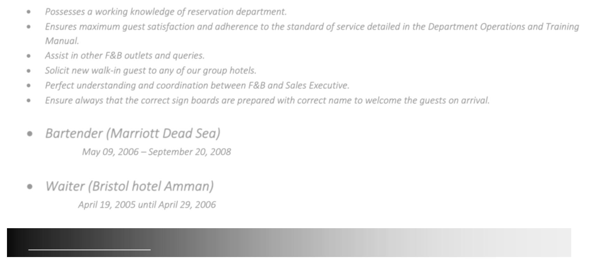
- Possesses a working knowledge of reservation department.

- Ensures maximum guest satisfaction and adherence to the standard of service detailed in the Department Operations and Training Manual.

- Assist in other F&B outlets and queries.

- Solicit new walk-in guest to any of our group hotels.

- Perfect understanding and coordination between F&B and Sales Executive.

- Ensure always that the correct sign boards are prepared with correct name to welcome the guests on arrival.

- Bartender (Marriott Dead Sea)

May 09, 2006 – September 20, 2008

• Waiter (Bristol hotel Amman)

April 19, 2005 until April 29, 2006

ACADEMIC EXCELLENCE:

No. | Course | Board/University | Institute/School | Year of
 |  |  |  | Passing
1 | TAD | 2 years literature | Govt. High School salah Al Dien | 2004
2 | BA | Hotel management | Amon collage bachelor degree | 2008
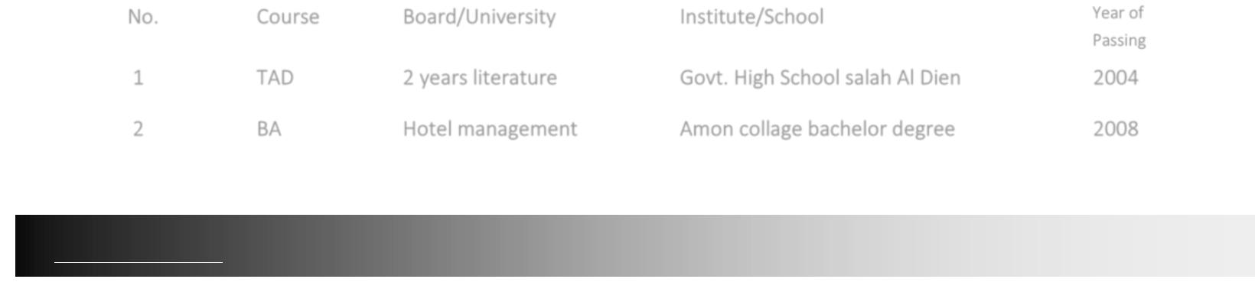

SPECIAL SKILLS:

- Professionalism.
- Ability to work as a team member.
- Communication skill.
- Excellent negotiation skills.
- Monitoring stock levels.
- Observes deadlines & achieves result.

- Demonstrated skills to use time effectively.
- Allocates appropriate time & resources for completing work.
- Adjust priorities as required.
- Planning & Organizing.
- Creativity.
- P&L and budgeting – costing

- Train the trainer
- Team coaching levels
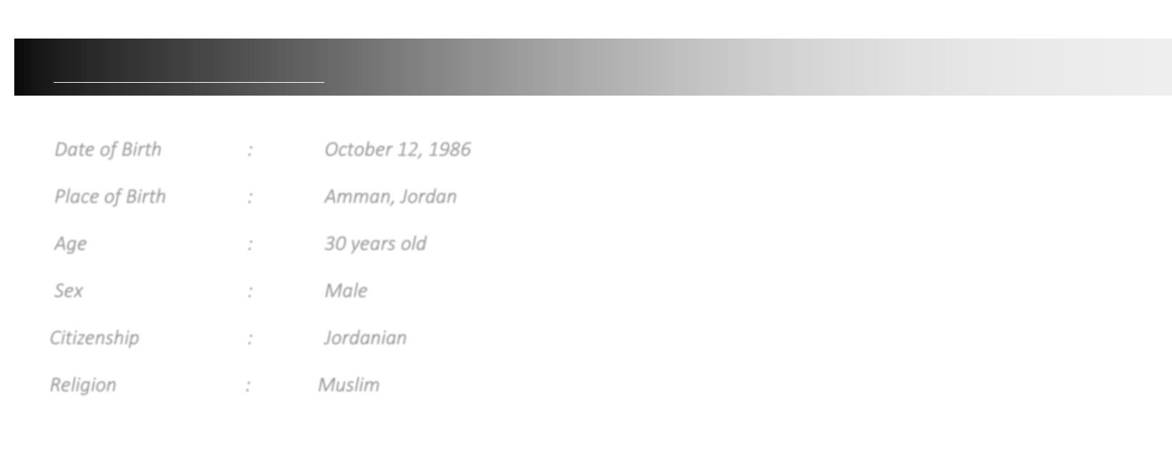

PERSONAL INFORMATION:

Date of Birth | : | October 12, 1986
Place of Birth | : | Amman, Jordan
Age | : | 30 years old
Sex | : | Male
Citizenship | : | Jordanian
Religion | : | Muslim

