Aman
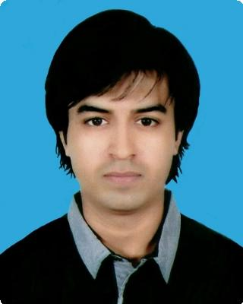

Aman.325979@2freemail.com

Objectives

Enhance my knowledge and skills by working practically in a good organization and gain as much experience as possible to achieve my goals and become a better engineer.

About Me
I am originally from Pakistan. I hold a Pakistani nationality but I've been a Saudi Citizen for more than 22 years. I am currently 23 years old, born on 23 June 1993. I am a hardworking person and passionate in my line of work. My education from primary to high school was in Riyadh, Saudi Arabia and I did my bachelor's degree in Mechanical Engineering from Universiti Tenaga Nasional in Malaysia. I have a valid Saudi driving license since 2010.

My skills and abilities include but not limited to:

Self-Motivation, Creativity and Passion. Work at my own initiative or in team.
Effective transparency in communication at all levels within an organization and beyond. Work in compliance with organization policy and behavior.
Excellent soft skills and habits.
Designing and IT skills (including MS Office, E-Marketing, Auto CAD 2D/3D, SolidWorks, ANSYS, etc.) Good Social Skills, Management Skills, Project Management Skills.
Event Organizing, Leadership and Interpersonal skills.
Quick Learning, Excellent Presentation and Communication Skills.

Work experience
Freelance March 2012 — February 2015

Designer

Freelancer - Product designer for university and college projects using AutoCAD 2D & 3D and SolidWorks.

SNC Lavalin Fayez Engineering February 2015 — May 2015

Internship

Mechanical Engineer - Design Engineer for rotating equipment, static equipment, piping and plumbing in oil and gas industry.

Freelance March 2015 — May 2015

Tuto 1

Freelance | June 2015 — August 2015
Part time - Merchandising & Sales
Merchandising & Sales for different brands.
Freelance | August 2015 — May 2016
Part time - Tutor
Home tuition - Teaching high school and foundation students.
Freelance | May 2016 — October 2016
Product designer / Product Analyst / Trainer

Freelancing - Product design and analysis projects for university and college students for capstone design and mechanical design subjects using SolidWorks, ANSYS and AutoCAD 2D/3D softwares.

Qualifications
2009 : O Levels Certification.
2012 : Foundation Certification in Engineering.
2015 : Industrial Training Certificate of Completion.
2016 : Certificate of Participation in Mechanical Design Process Exhibition.
2016 : Certificate of Training in Non-Destructive Testing.
2016 : Certificate of Participation in Capstone Design Exhibition.
2016 : Executive Diploma in CAD.
2016 : Executive Diploma in Product Design & Analysis.
2016 : Bachelor’s Degree in Mechanical Engineering.

Education
O levels | September 2007 — June 2009
Pakistan International School English Section
Cambridge International Examinations, British Council, Riyadh, KSA
Foundation in Engineering | October 2010 — February 2012
Universiti Tenaga Nasional
Putrajaya Campus, Malaysia
Executive Diploma in CAD | August 2016 — August 2016
Six Sigma Synergy - CADD Centre
Petaling Jaya, Malaysia
Executive Diploma in Product Design and | August 2016 — September 2016
Analysis
Six Sigma Synergy - CADD Centre
Petaling Jaya, Malaysia
BSc. Bachelor in Mechanical Engineering | May 2012 — October 2016
(Hons.)
Universiti Tenaga Nasional
Putrajaya Campus, Malaysia

Aman Ullah Ashraf 2

Interests
Aviation/Aeronautics
Automobile
Management
Oil & Gas Industry
Designing (AutoCAD 2D/3D, Solidworks, ANSYS)
Sports (Futsal, Football, Badminton)

Visa Status
Currently on UAE Visit Visa valid until 22 January 2017.

References
References available upon request.

Aman Ullah Ashraf 3

