RESUME
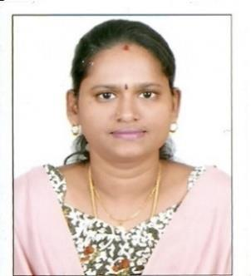

PERSONAL DETAILS:
NAME: | GOMATHI  GOMATHI.326296@2freemail.com

LANGUAGES KNOWN:

ACADEMIC QUALIFICATION:

SPOKEN | WRITTEN
ENGLISH,TAMIL,HINDI | ENGLISH &
& MALAYALAM | TAMIL

M.COM.

 | MADRAS UNIVERSITY, CHENNAI,
B.COM | TAMIL NADU.
 | ANNAMALAI UNIVERSITY,
M.COM | CHIDAMBARAM, TAMIL NADU.
TECHNICAL QUALIFICATION:

- TYPEWRITING: ENGLISH & TAMIL HIGHER PASSED

- COMPUTER: 1. ADVANCED DIPLOMA IN COMPUTERS,

APPLICATION AND INTRODUCTION TO COMPUTER WINDOWS,

MS-OFFICE AND FOXPRO.

2. DIPLOMA IN OFFICE AUTOMATION AND TALLY.

ADDITIONAL QUALIFICATION: HINDI RASHTRABASHA PASSED

THROUGH DAKSHINA BHARATH HINDI PRACHAR SABHA, CHENNAI.

WORK EXPERIENCE: WORKED AS A TYPIST AND ASSISTANT
ACCOUNTANT IN AN OFFICE AND ALSO WORKED AS TEACHER IN INDIA AND

ABUDHABI.

PROFESSIONAL OBJECTIVE:

SEEKING A SUITABLE AND REWARDING CAREER WITH AN ESTEEMED
ORGANIZATION. THIS WOULD OFFER GOOD ADVANCEMENT POTENTIAL
CHALLENGES AND OPPORTUNITIES TO ZOOM MY CARRIER GROWTH ALSO

CONTRIBUTING TO THE SUCCESS OF THE ORGANIZATION.

PERSONAL STRENGTH:

EXCELLENT COMMUNICATION SKILL.

HIGHLY COMMITTED TOWARDS THE ASSIGNED

RESPONSIBILITIES.
HARD WORK, SELF-MOTIVATED AND INDIVIDUAL.

HIGH GRASPING POWER AND A FAST LEARNER.

TEAM WORKER AND CO-OPERATIVE IN NATURE.

ACKNOWLEDGEMENT

I HEREBY DECLARE THAT ALL THE ABOVE MENTIONED DETAILS ARE TRUE AND

I WILL BE THE ASSET FOR THE ORGANIZATION THROUGH MY SERVICE.

THANKS AND REGARDS,

