Karim
Karim.326307@2freemail.com

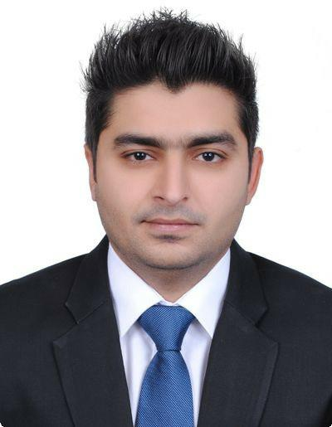Entrepreneurial Marketer passionate about building productive relationships with clients, partners and team members. New customer acquisition expert who emphasizes a mix of online and offline marketing strategies. Well-versed in identifying market trends and customer needs to create highly-targeted marketing campaign
Highlights
• Brand development | • Trade shows
• Multi-media marketing | • Knowledge of market trends
• Strategic media placement | • Business development
• New customer re-acquisition | • Brand recognition optimization
• Account management | • Stake-holder relations
Experience
04/2014 - Marketing and Sales Manager
Present Anila Gem International Co.Ltd Bangkok, Thailand
- To develop good working relationships with potential customers by arranging meetings and appointments at international jewelry fairs.

- Creative handling of sales promotional activities of products.
- Mapping consumer insights, devising brand strategies & execute integrated marketing programs to enhance customer experience & sales efforts.
Accomplishments:

- Captured new clients at trade shows and generated profitable revenues resulting in sales at 80% of capacity for the full season also recovered 37% of lost customers which increased the general sales by 72%.

- Successfully launched a luxury brand named “INNAYA” for high end customers & promoted it at a high end to North America by personal visits.

- Captured new markets (wholesalers & Retailers) from USA.
11/2011 - | Priority Relationship Manager
03/2014 | Standard Chartered Bank Karachi, Pakistan
 | • | Maintaining good public relationships with the clients to generate business.
 | • | Giving Sales Presentations to the prospective clients to convince them to retain
 |  | the amount till the end of the month.
 | Accomplishments:
 | • | Utilized cross selling and direct marketing techniques to focus potential clients.
 | • | Surpassed monthly sales goals by 120% on average for the last 1 year.
11/2008 - | Marketing and Sales Executive
09/2011 | Millat Industries (Pvt) Ltd. Karachi, Pakistan

Education
01/2011 - PAF-KIET Karachi, Pakistan

12/2013 Masters of Business Administration (MBA-Marketing) CGPA 3.2/4.0

05/2012 University of Karachi Karachi, Pakistan

MA-Economics

Interests

Travelling overseas and exploring new markets

Nationality
Pakistan

Skills
Interpersonal and communication
Teams Managed of 5-8
Microsoft Office

Adobe Photoshop

Languages
English

^{Thai}

Arabic

