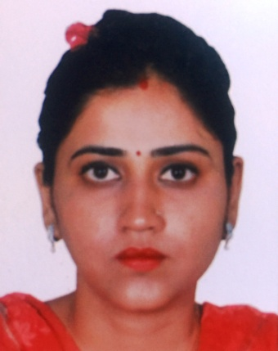
Manpreet
Manpreet.326410@2freemail.com

Customer service professional with 8+ years of experience in Front Office & MIS. Familiar with major customer service software, conflict resolution and possess a positive attitude.
Aiming to use my proven skills to effectively fill the senior position in your company.

Professional Qualification :-

Knowledge in Analysis Reports, Presentations, MS-Excel, MS Access, CRM, BSCS (Business support control system).

Experience Summary:

Organization | Designation | Duration
Consulting Engineering Group (CEG) - Jaipur | Customer Service Executive | July 2015 – Aug 2016
 | Senior Billing Executive | Dec 2010 - May-2015
Vodafone Digilink Ltd
Vodafone Digilink Ltd | Front Line Customer Care Executive | April 2008 - April 2010

Consulting Engineering Group (CEG) - Jaipur

Customer Service Executive (CEG) July 2015 – Aug 2016

- Handle customer inquiries, complaints, billing questions and payment extension/service requests.
- Listing new company in company database for future transaction.
- Manage customer’s accounts.
- Keep records of customer transactions.
- Preparing and maintaining daily activity report.
- Distribute customer’s reports daily basis.
- Attending incoming calls .
- Maintains cash and cheque daily basis.

Vodafone - Jaipur

Senior Billing Executive ( MIS Analyst) Nov 2010 – July 2015

- Manage the status of accounts and balances and identify inconsistencies.
- Issue and post bills, receipts, data and invoices. Check the validity of debit accounts.
- Update accounts receivable database with new accounts or missed payments.
- Ensure all clients remain informed on their outstanding debts and deadlines.
- Provide solution to any relative problems of clients.
- Prepare reports on billing activity with clear reliable data.
- Maintains daily MIS of bill distribution, credit & debit account for more than two hundred thousand customer of Rajasthan Circle – India. .

Vodafone - Jaipur

Customer Care Representative April 2007– Nov 2010

- Manage a high-volume workload within a deadline-driven environment (Attends 100+ Customers per day) and consistently met performance benchmarks in all areas (speed, accuracy & volume).
- Attend inquiry regarding products & services.
- Advised customers regarding plan/payment options as per their requirement & that will suit their budget.
- Receive bill payments from customers; discuss billing questions and service concerns.
- Selling Prepaid and GSM Postpaid SIM cards, Smart phones, etc.
- Introducing the newest technology, trends in the market and discussing the technical specifications.
- Provides customer satisfaction by resolving their complaints.

Personal Profile

Marital Status Married
Visa Type Resident
Linguistic Capabilities English, Hindi, Punjabi.

