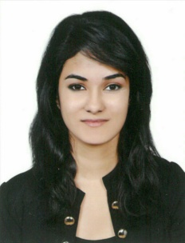

PRETTY

PRETTY.326414@2freemail.com

CAREER OBJECTIVES:

A hardworking and ambitious individual looking forward to make a sound position in corporate world and work enthusiastically to achieve goal of the organization and to succeed in an environment of growth and excellence provided with job Satisfaction and self-development.

EDUCATION QUALIFICATION:

- Masters in International Business(MIB) - University of Wollongong Dubai
- Bachelors of Commerce- Madras Christian College Chennai (2010-2013) (Specialized in both Human Resource Management and Accounting)
- Higher Secondary Education – Indian School, Al-ain- UAE

SKILLS:

- Leadership Qualities
- Hardworking and Determined in completing the assigned task on time
- Good Communication skills, verbal and written
- Exceptional ability to work individually or as a team player.
- Good presentation skills
- Healthy competitor for the best performance

COMPUTER SKILLS:
Ms.Word, Ms. PowerPoint, Ms. Excel, HTML, JD Edward (Oracle)

EXPERIENCE:
- Account Executive in Nael and Bin HarmalHydroexportfor 1 year (22 Aug 2014- 22 Aug 2015)
- Accounts payables (Invoicing, Petty cash, Salaries, Payments)
- Dealing with suppliers

- Intern at Axis Bank
-Worked as an intern at Axis Bank in Chennai for a period of 1 month
- Attained knowledge about the Banking system as a whole
- Highly involved with the customer service department of the bank and dealt with opening of accounts and provide sufficient information to the Axis bank customers about the Loans available and their benefits and interest period.
- Learnt about Cheque clearing and its functions and importance
- Gained information on elimination of errors and fraud in banking transaction

LANGUAGES KNOWN:
English, Malayalam, Hindi, German (Basic), Tamil and Arabic (Basic)

ACHIEVEMENTS:

- Prefect of Indian School Al-Ain,U.A.E
- Won medals and Certificates in Sports
- Won Certificates in Co- Curricular Activities
- Scored 7.5 in IELTS (2013)

PERSONAL INFORMATION:

Date of Birth :11 -11- 1991
Nationality : Indian
Marital Status : Single
Visa Status : Residence Visa (Father’s Sponsorship)
Holder of UAE Driver’s License

