RESUME 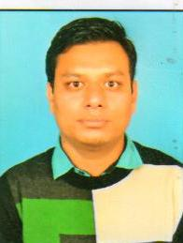
ASHOK
Email:- ashok.326505@2freemail.com

Career Objective:
Seeking a challenging career in a professional organization, where I can use my skills/ knowledge and intelligence to add value to an organization and to become a leader in my field

Qualifications:
EXAM  DEGREE | YEAR | INSTITUTION | UNIVERSITY/ BOARD | PERCENTEGE
B.B.A | 2013 | DAYANAND  COLLEGE  AJMER | M.D.S  UNIVERSITY  AJMER | 60.76%
12th Board | 2010 | GOVT.S.SEC. SCHOOL. MAROTH | R.B.S.E | 62.00%
10th Board | 2008 | GOVT.S.SEC  SCHOOL  MAROTH | R.B.S.E | 51.77%

experience:
Company name | Address | Position | Timing
IMSC (international management system certification ) | Vadodara | Office administration and marketing executive | Nov 2013 to April 2014
Ace diagnostics  G.c.c Approved hospital | Jaipur | Cashier | July2014 to till continue
Technical Skill:
- C, C++, Java, internet and basic knowledge
Strengths:
- Self Motivated & Attitude
- Suitable to Work Any Environment
Hobbies and interest:
- Net Surfing
- Listening Music
- Making new friends
Training undergone:
- Organization : AZDUSS LTD AJMER 2011
- Description : It is a milk Company
Personal details:

Date of birth : 4 January 1992

Language known : English, Hindi

Gender : Male

Marital Status : Unmarried
Declaration
I hereby declare that above information is correct to the best of my knowledge and belief.

