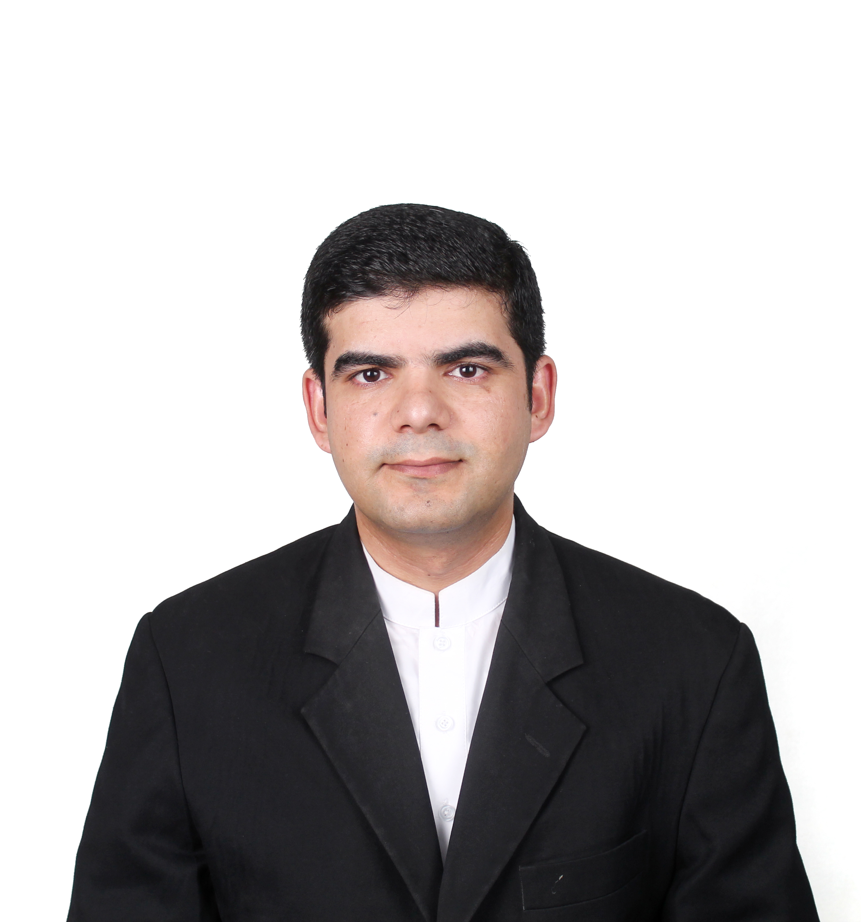
Abbas
PHARMACIST (HAAD)  (HEALTH AUTHORIY OF ABU DHABI) | Email:abbas.326966@2freemail.com
UAE Driving License

Career Objective

Strive to exceed employer expectations by delivering second-to-none service. To pursue a success oriented carrier an ever challenging and dynamic field of pharmacology & therapeutics. Believe in high quality administration maintain organization centricity in all initiatives and interactions, always putting the organization first. I believe your organization is a place where I can excel by utilizing my potential and broaden my horizon by complementing the theoretical knowledge with practical experience of the professional life.

Academic Credentials

Pharm D (Doctor Of Pharmacy) | Sarhad University Peshawar, Pakistan | 2006 - 2012
Intermediate (Pre Medical) | Agricultural college Peshawar,pakistan | 2003 - 2005
Secondary School Certificate  (SSC) | BISE peshawar Pakistan | 2002 – 2003

Work Experience

1. 1 & 5 months Year Work Experience in ALI MEDICAL COMPNY PAKISTAN

Responsibilities:
- To cooperate with physicians regarding prescription of Drugs.
- To check the prescription about the possible drug interaction, contraindication and adverse Drug reactions.
- To council the patient about right administration of drugs and their side effects.
- Meeting with Sales Representatives of different Pharmaceutical Firms for purchasing of theirs products.

2.COMPLETE ONE YEAR OF PHARMACIST TRANIEE IN EMIRATES INTERNATIONAL HOSPITAL AL AIN ABU DHABI
Responsibilities:

- Dispensing to the patient (under the supervision of preceptor)
- Giving appropriate information about the use of medicine to the patient(under the supervision of preceptor)
- Taking care of medicine owns shelf,proper storage,arrangement provide availibilty of shortage of medicine.
- Checking for the patients history files
- Patient councilling(under the supervision of preceptor)
- Making rounds in different wards of patients with physician,senior pharmacist and other medical and paramedical staff of the hospitals

3. From TWO YEARS in EMIRATES INTERNATIONAL HOSPITAL AL AIN ABU DHABI AND STILL.

Responsibilities:

- To cooperate with physicians regarding prescription of Drugs.
- To check the prescription about the possible drug interaction, contraindication and adverse Drug reactions.
- To council the patient about right administration of drugs and their side effects.
- Inventory control of drugs in hospital.
- Coordinate with health insurance companies regarding patients’ cases.
- Verify and dispense medications to inpatients and outpatients.
- Counsel patients about safe and appropriate use of their medications, precautions, drug/food interactions, drug/drug interactions, and answer their questions about the therapy and ensure patient confidentiality.
- Prepare, label, handle, and distribute IV admixture under aseptic conditions after verification of their compatibilities.
- Responsible for cheking the medicine in trollies and crashcart of 3operation theatres
- Verify and check all filled prescriptions, ward stock orders, repacked medications for correctness of product, dosage form, quantity dispensed and to ensure quality labelling.

IT Skill Set

MS Offices | : | Microsoft Office, Power Point, Ms Excel
Web Browsing | : | Web Browsing and Internet
Operating system | : | Windows Xp/7/Vista

Academic Projects

- 1. NAUSEA AND VOMITING.
Thesis and research on “The Role of Pharmacist (Doctor of Pharmacy) in the treatment of Nausea and vomiting.” in North West General Hospital Peshawar Pakistan. (Right drug for the right patient in a right time with a right dose, to avoid the side effects, adverse effects, over dosages, contraindications and drug-drug interactions.
Personal Dossier

Date of Birth | 20 APR 1987
Marital Status | Married
Residence | Al Markhaneya,Al Ain,Abu dhabi, UAE

Passport Details

Place of Issue : Pakistan
Date of Issue : 08 FEB 2012
Date of Expiry : 06 FEB 2017

Languages:

- English (Fluent)
- Urdu (Fluent)
- Pashtu (Native)
- Arabic (Good)

Success Factors:

- Excellent Planning Skills.
- Good Interpersonal & Communication Skills.
- Ability To adjust & work in a Tough working
Environment and learn quickly.
- Helping in implementation of Company Rules &
Policies
- Excellent Knowledge of Pharmacology and therapeutics.

References:

Will be provided if asked......

