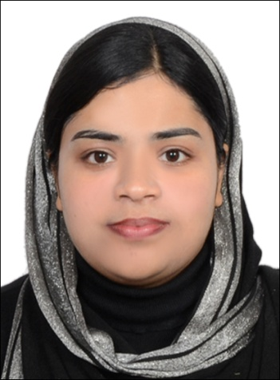
CURRICULUM VITAE

NAZEERA
NAZEERA.326985@2freemail.com

CERTIFIED MONTESSORI ( U K ) / EARLY CHILDHOOD- EDUCATOR ( Ages- 0 to 6 years )

U.A.E. Teaching License : Qualified to teach from KG to Grade 3 as per Ministry of -
Education, U.A.E.

WORK EXPERIENCE: Above 9 Years as Kindergarten Teacher in both UK &
American Curriculum + Montessori - Method of Teaching.

CAREER OBJECTIVES : As a dedicated Kindergarten / Montessori teacher eager to resume full-time teaching career and offer a proven track record of commended performance teaching grades KG1- Grade 3. With a passion for education and an unwavering commitment, I would like to enhance my knowledge by joining in a reputed institution and become a valuable asset for both the organization and for the students by utilizing my talents, creative capabilities and commitment to attain organizational goals as well as personal goal.
CORE COMPETENCIES
- Creative Lesson Planning  - Curriculum Development  - Instructional Best Practices  - Classroom Management &  Discipline | - Standardized Testing / Scoring  - Learner Assessment  - Experiential Learning  - Special Needs Students/ IEPS

PROFESSIONAL EXPERIENCE

1. Presently working as Kindergarten Class Teacher in Al Adhwa Private School ( American Curriculum ),
Al-Ain, U.A.E. (since 2011)
2. Worked as Montessori Teacher & Montessori Trainer in Global English School ( Accredited to
Cambridge University, U.K ) Al-Ain ,U.A.E.(year 2009-2011)
3. Worked as Kindergarten Teacher in Indian School, Fujairah, U.A.E , ( year 2007 -2008 )
4. Worked as Montessori Teacher in Muslim Educational Society Central School
( M.E.S ),Tirur, Kerala State, India.

Key Contributions:

- Earned high marks for the quality and creativity of classroom teaching, lesson plans and instructional materials used in teaching diverse subjects(e.g.,language arts,mathematics,science)
- Developed innovative approaches that were repeatedly held up as the model standard for meeting goals in areas including,integration across the curriculum,experiential learning, literacy & diversity.
- Consistently commended for ability to redirect students exhibiting behavior problems by replacing disruptive, unproductive patterns with positive behaviors.
- Actively served on a variety of school committees and task forces focused on curriculum development, textbook review, fund raising and anti-bullying efforts.
- Established positive relationships with students, parents,fellow teachers & school staffs.
- Personally requested by many teachers to take over their classrooms during absences.

PROFESSIONAL ACHIEVEMENTS & SKILLS

- Undergone Montessori Instructors Training from Singapore ,under MMI ( year 2007 ).
- Trained by Foreign Faculties from London, Singapore and Malaysia.
- Able to set up a Montessori Classroom & its environment, Purchase & Ordering of Montessori Materials.

QUALIFICATIONS
Medium of instruction - English

Course | Month & Year-Passed | Percentage ( % ) of Marks Obtained / Board of examination
Diploma In Modern Montessori International Teacher’s Training | June, 2007 | Distinction with 89 % / London Board of examinations, London, U.K -training from M.M.I. - India
Bachelor of Arts & Sociology | March, 2005 | Second Class with 54 % / B.A. Graduate from Calicut University, Farook College, India
Higher Secondary School | March, 2002 | Distinction with 80 % / Higher Secondary School Exam, Calicut Girls V.H.S.S.,India
Secondary School | March, 2000 | First Class with 60% / Secondary School Examination, Venerni English Medium Girls High Schoo, India

Concerned Subjects : Child psychology, Montessori Philosophy, Practical Life , Sensorial, Language Mathematics, Cultural, Child Development and Curriculum

PERSONAL DETAILS :
Nationality : Indian
Age & Date of Birth : 31 Years, 01-11-1983
Marital Status : Married

LANGUAGES KNOWN :
To Read, Write and Speak : English, Hindi, Malayalam and little Arabic

DECLARATION : I do hereby declare that the above information are true and correct to the best of my knowledge and belief.

