Curriculum vitae

Name Sami
Nationality Egyptian
YearofBirth 1982
MaritalStatus Married
Email Sami.327209@2freemail.com
Year of Graduation 2004
SUMMARY .
I have 12 years of diverse construction experience in Dubai with strong technical and contractual work practice in a numerous landmark and luxurious projects including high rises,hotels, residential and commercial buildings, I am a dedicated performer with strong leadership skills and professional manner, I have developed multi-tasking and organizational skills in Design,Planning, Project Risk Management and Contracts Administration (Technically and Contractually)
KEY QUALIFICATIONS

Education

BSc. Civil Engineering - Alexandria University - Egypt - June 2004

Computer Skills

Good using of Structural Analysis Program (Sap 2000), Primavera Project Planner (P3), Drawing programs (AutoCAD 2010),
Survey Program (Surfer) / Instruments (Dumpy Level and Total Station), Microsoft Office (Word, Excel)

Professional Training

Completed the following Professional courses at the American University in Cairo AUC:

- Sap2000 : 2003
- SapAdvanced :2005
- Primavera :2005

Language Capability

- English Verygood
- Arabic Mothertongue

EXPERIENCERECORD

Company Khatib&Alami(Consolidated Engineering Company) – Dubai-U.A.E.(March2006–Present)

Designation Chronology

- Resident Engineer (June 2014 –Present)
- AssistantResidentEngineer(May2011–June2014)
- Site Engineer (March 2006 – May2011)

March 2017 – Present

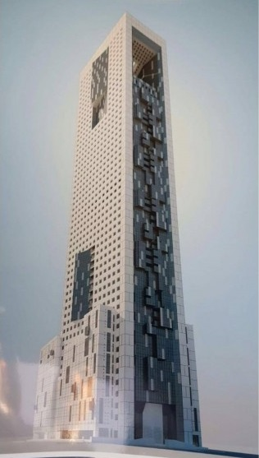

June 2014 – March 2017
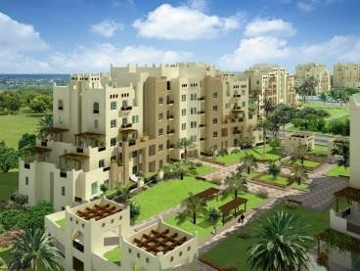

Responsibilities

Client : The Gate Trading

Contractor : Al Qabdah Global Building Contracting –QBC

Project Name : The Gate Tower – B+ G + M + 8 P + 50, Multi Use . Tower –Retail, Offices and Residential Tower

Contract Value : 400 Million AED

Designation : Resident Engineer

Client : Dubai Properties

Contractor : Engineering Contracting Company -ECC

ProjectName : Al Remraam Housing Community – Phase 2 -18Bldgs.Contract Value :600 MillionAED
Designation : ResidentEngineer

  - Leading,managingandmotivatingthesupervisionsiteteam
  - Monitoring the work progress at site and the procurement / delivery of items fall under long lead materials based on the baseline schedule and identify the key milestones , critical activities and operating constraints
  - Reviewing and handling the project’s material and technical submittals including shop drawings, method statements , RFI’s and work program in coordination with all various disciplines
  - Coordinating and following up with the client , authorities and involved stakeholders to steer the project towards its successfulcompletion
  - Ensuringpostcontract-prestartdocumentationsofthecontractorsareinplaceandincompliancewiththe contractrequirements – like reviewing the legal clauses and proficiency of the construction different insurances policies , submitted ponds and guarantees , program and KPI’s , Logistics plan, QA/QC plan and safety Plan
  - Leading/participatinginallsiteprogress,technical, commercial , workshop and management meetings
  - Administrating the contract by reviewing ,coordinating and handling all contractual correspondences , EOT claims , variations orders – change management procedures , PC items and PS tender floating and analysis, ensuring all information is accurate and in accordance with the contract documents
  - Reviewing the interim payments , cash flow and other financial issues in coordination with the QS
  - Ensuring the proper implementation of safety and quality measures in line with the pre- approved safety and quality plans and issuing instructions as necessary to rectify safety violations
  - Review and analyze with the design team any Value Engineering Exercise proposed by the contractor with respect to its impact on the Project’s Triple Constraint , and assist the Employer to trade-off between different alternatives , assesses gains and losses to reach better understanding

May 2011 – June 2014

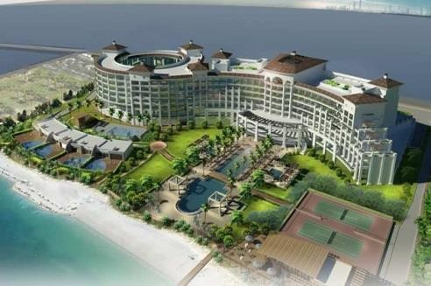
Client : Al Habtoor Group

Contractor : Al Shafar General Contacting - ASGC

Project Name : Waldorf Astoria – 5 stars Resort and Spa - Dubai Palm Jumeirah Contract Value : 800 Million AED
Designation : Assistant ResidentEngineer
Responsibilities
  - Monitoringtheworkprogressandtheoverallprojectplans,schedulesandmilestonesandleading/guide the supervision siteteam
  - Reviewingandhandlingtheproject’smaterialandtechnicalsubmittalsincludingshopdrawings,method statements , RFI’s and work program in coordination with all variousdisciplines
  - Managing deliverables , Contribute to technical solutions on the project and Initiate / participate in design constructabilityreviews
  - Coordinatewiththedesignteams,contractorsandsubconsultantstoresolvetechnicalissuesandobtainthe requiredapprovals
  - Assistingtheprojectmanagerinadministratingthetechnicalandcontractualaspectsofthecontract

June 2008 – May 2011

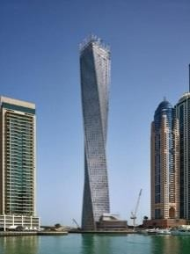
Client : Cayan Group

Contractor : Arabtech

Project Name :Cayan Tower, 6B+G+M+80 – The world’s tallest twisted tower
ContractValue : One Billion AED
Designation : SiteEngineer

March 2006 – June 2008

Responsibilities

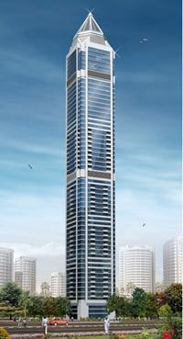
Client : Al TayerReal Estate
Contractor : Al Shafar General Contacting – ASGC
Project Name :Al Tayer Tower - 3B+G+M+65 TYP.
Contract Value :315 MillionAED
Designation: SiteEngineer

- Monitoring and witnessing samples collection and testing on and off-site
- InspectingeachandeverypartofworksandallmaterialsdeliveredtositeandinitiatingSI’sandNCR’sasrequired
- Ensuring proper implementation of works as per method statements , specifications , design / shop drawings and the work program logicalsequence
- Reviewing the project’s shop drawings, technical submissions, coordination works and method statements
- Reporting to the project manager and preparing all required progress and technicalreports

Jan 2005 – Feb 2006 Militaryservice–EgyptianNavy–EngineeringDepartment(workedatBldg.’srenovation, concretestrengtheningandstructuralrehabilitations)
End of CV

