CURRICULUM VITAE
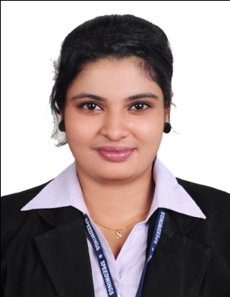

MARY SRUTHI
mary.327260@2freemail.com

CAREER OBJECTIVE
Seeking a reputed position where I can utilize my knowledge, abilities and personal skills while being resourceful, innovative and flexible that offers professional growth along with organization.

ACADEMIC QUALIFICATION
- Bachelor Of Business Administration with Aviation Operation, University Of Petroleum And Energy Studies, Dehradun, Speedwings Aviation Academy, Ernakulam, Kerala, 2015
- IATA-Air Cargo, Speedwings Aviation Academy, Ernakulam, Kerala, 2014
- IATA-UFTAA , Speedwings Aviation Academy, Ernakulam, Kerala, 2014
- St. Mary’s Anglo. Indian. Girls. Higher. Secondary. School, Ernakulam, Kerala, 2012
- St. Mary’s Anglo. Indian. Girls. High. School, Ernakulam, 2010
ACCOMPLISHMENT AND STRENGTH
- Ability to work independently and as a part of a team.
- Ability to deal with any stressfully situation diplomatically.
- Learn and acquire knowledge to my work.
- Possess Good Communication and Interactive Skills.
- Detail Oriented and resourceful in completing responsibility.

PROFESSIONAL QUALIFICATION
- IATA- CARGO INTRODUCTORY
- IATA- FOUNDATION IN TRAVEL and TOURISM\

TECHNICAL KNOWLEDGE
- MS Word
- MS Excel
- MS Power Point
- Tally
- GDS : Amedeus
- GDS : Abacus
- GDS : Worldspan
- GDS : Galileo
EXPERIENCE
- Worked as Counter Staff in Destination Holidays Tours & Travels. (5 months)
- Worked as Customer Service Agent in Air India SATS Airport Service PVT LTD. at Trivandrum International Airport. (8 Months)
- Worked as a Sales Coordinator in Manchester Shipping LLC. At Jebel Ali FZE, Dubai. (6 Months )
LANGUAGE ABILITY
- English : Read, Write, Speak
- Malayalam : Read, Write, Speak
- Hindi : Read, Write, Speak
PERSONAL DETAILS
Date of Birth : 30/06/1994
Nationality : Indian
State : Kerala
Country of Birth : India
Sex : Female
Marital Status : Single
Religion : Christian
Caste : Latin
Visa Status : Transferable Visa

DECLARATION
I hereby certify that all the information stated above are true and complete to the best of my knowledge and belief.

