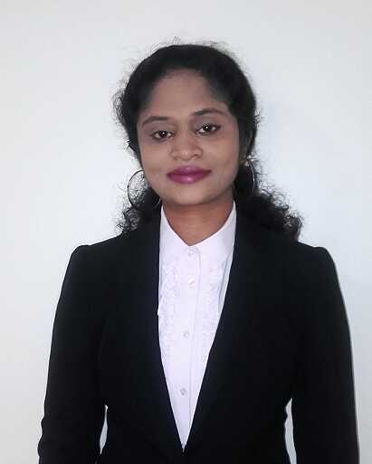
Anitha
Anitha.327371@2freemail.com

OBJECTIVES

Seeking foropportunity to continue my career in teaching field.

KEY SKILLS

- Excellent Communication skill.
- Excellent command over comprehension
- Strong knowledge of utilizing all the modern teaching aids.
- Ability to handle children of different age groups.
- Expertise in using new teaching methodology to explain difficult topics.

STRENGTH

- Enthusiastic and hardworking
- Possess positive attitude
- Responsible towards work
- Self-motivated and directed

EMPLOYMENT

- June 2008 toApril 2010 : St. Ann’s SchoolKuntikan , Mangalore

- Jun 2011 to October 2016 : Infant Mary School Katipalla, Mangalore

RESPONSIBILITY
- Inculcate model behavior mannerism by self-example.
- Prepare long term teaching programs and daily lessons in accordance with the guidelines of the school’s education system.
- Provide activities and materials that engage and challenge the students intellectually.
- Shift between formal and informal methods of teaching like debates, discussion, practical activities, experiments, projects and excursion.
- Be ready to adjust teaching style to meet individual needs of students.
- Supervise student conduct during class, lunch time and other breaks.
- Enforce discipline by firmly setting classroom rules.
- Understand the diverse back ground students come from, their strengths, weakness and area of interest.
- Understand and implement the use of information technology in lesson preparation and teaching.

EDUCATIONAL QUALIFICATION

 | Qualification | Year | University
 | M.A (Hindi) | 2015 | Dakshina Bharat Hindi Prachar Sabha,Madras - Post Graduate And Research Institute
 | Shiksha Snatak (Hindi)(B.ed) | 2015 | Dakshina Bharat Hindi Prachar Sabha,Madras - Post Graduate And Research Institute
 | Rashtrabhasha Praveen (Hindi) (B.A) | 2014 | Dakshina Bharat Hindi Prachar Sabha,Madras
 | D.Ed | 2007 | St. Ann’s T.T.I College, Mangalore
 | PUC | 2005 | Narayana Guru PU College, Katipalla
 | SSLC | 2003 | Little Flower High School, Kinnigoli

PERSONAL PROFILE

Date of Birth 6 July 1988
Marital Status Married
Nationality Indian
Languages Known English, Hindi

I hereby declare, that the information given above is true and to the best of my knowledge.

