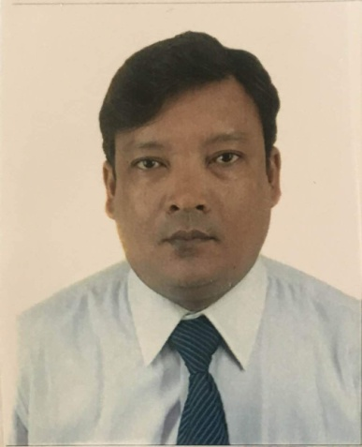
RITESH
RITESH.327423@2freemail.com

Curriculum Vitae

Work Experience
10.13–04.15 Purchase Coordinator & Logistics, Cosmic Interior Design, Dubai, UAE
Coordinate with subcontractor, Local Purchase Order with Supplier, Logistics Transportation planner for the Project site area and overseas site, shipment paper work, wood materials, hardware building materials, event Buildup and dismantle work planner, equipment tools and coordinate with vendor , negotiate price, public relation, marketing management , material management track missing items from order maintaining log on partial releases for large purchase order etc.
12.11–01.12 Purchase Electrical Coordinator, James Electrical, Goa, INDIA
Process and distribute purchase orders to vendors and subcontractors, Maintaining Log on partial releases for large purchase orders, Price comparison on all small electrical orders, place order for next day delivery to jobsite to jobsite, Interacted with sales and or the account to resolve shipping delays and/or obstacles as efficiently and cost effective as possible, Preparation of submittals and operation/maintenance manuals, Receive/approve vendor/subcontractor invoices; reconcile and release payments, Worked closely with Supervisor on Lighting jobs (i.e. verify fixture counts, create and organize files, request RFI (Request for Information) from Electrical Contractor, Process change Orders, Track missing items from orders Maintaining Log on partial releases for large purchase orders, General Administrative duties, such as answering incoming calls, filing, faxing, copying and mailing, Office management and Purchase Electrical Lighting quotation and order, coordinate with client and arrange the materials to direct to supplier,etc 
08.07–01.09 Project Secretary & Admin, City Engineering Contracting, Dubai, UAE
Office clerk work, Site Project Document Controller, Consultant Engineering Correspondence work, Sub-Contractor (MEP) Correspondence Details, Project Details, Material delivery records, Minutes Meetings etc.  

Higher Education
06.01–08.03 Bachelor of Computer Application (4Th SEM) IGNOU, Delhi, INDIA
Computer Application
07.96–06.97 High School (secondary Level), School of Govt, Gorakhpur, UP, INDIA
Mathematics and Science
07.96–06.97 High School, School of Govt, Gorakhpur, UP, INDIA
Science

Other Education
11.15–05.16 British Language of English study Center, Delhi, INDIA
ILETS - 4.5 Overall

Skills
Language skills: Fluent in Hindi; Intermediate in Swedish,
Computer skills: Mac and PC, MS-Office (Advance), Hardware OS

Other- References upon on request

