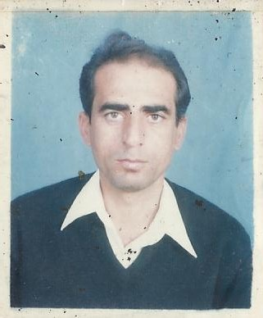***Zafar***

***Zafar.327432*** ***@2freemail.com***

***CAREER OBJECTIVES***

*To enhance career prospects using my existing ability, skills and knowledge*

*and to constantly improve them by working with an organization that provide*

*a challenging and growth environment while being resourceful innovative and*

*flexible.*

***STRENGTH***

* *Ability to handle multiple task, take initiative and organize priority*
* *Can be counted upon to achieve results independently and within team environment*
* *Strong public relation and communication skill,good interpersonal skills.*

***PROFESSIONAL HISTORY***

***1.. COMPANY…….****bu hamad contracting L.L.C DUBAI from 28.11.2011 to 15.12.2015*

***Occupation****….. general electrical engineer*

***RESPOSIBILITIES HELD.***

* *To prepare electrical drawing and load distribution schedule*
* *To design load cable and switch gears for the site.*
* *To execute and supervise electrical work on site*



***2.. COMPANY…….****system construct Dubai from 15.05.2007 to 20.11.2011*

***Occupation****….. general electrical engineer*

***RESPOSIBILITIES HELD.***

* *To prepare electrical drawing and load distribution schedule*
* *To design load cable and switch gears for the site.*
* *To execute and supervise electrical work on site*

***3.. COMPANY……****Peshawar electric supply company(PESCO)*

*From 10.02.2003 to 20.03.2007*

***Occupation…..****assistant engineer*

***RESPONSIBILITIES HELA***

* *To carryout necessary maintenance on 11kv overhead lines.*
* *To maintain smooth supply of electricity.*
* *To maintain balance load on 11/.4kv transformers*
* *TO carryout necessary maintenance of 11/.4kv transformers*

***EDCTION QUALIFICATION***

***1****… B TECH.HONS in electrical engineering*

***Year of passing……………………2002***

***Institute………………****university of engineering and technology Peshawar*

*Pakistan****.***

***2….B.TECH PASS in electrical engine***

***Year of passing……………………1994***

***Institute…….. ……….****university of engineering and technology Peshawar*

*Pakistan****.***

***3…Diploma of associate engineer in electrical technology***

***Year of passing…………………….1992***

***Institute…………………..****GOVT.college of technology Peshawar Pakistan*

***COMPUTER SKILLS***

* ***.*** *AUTO CAD 2D*
* *MS WORD AND EXCELL*