RESUME
Sudheesh 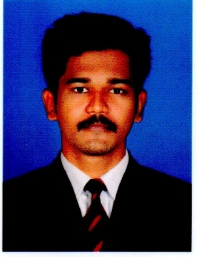
Email: sudheesh.327667@2freemail.com
PERSONAL DATA
PERSONAL DATA

PERSONAL DATA

Religion : Hindu,Pulaya
Date of birth : 09-01-1994
Gender : Male
Marital Status : single
Nationality : Indian
CAREER OBJECTIVE

To make a sound position in the corporate world and work enthusiastically in team to achieve the goals of the organization as well as personal with devotion and hard work.
ACADEMIC DETAILS

Year | Course | School/college | Board/ university | Marks%
2016 | MBA finance & marketing | Mangalam college of engineering and management | MG university | 63%
2014 | B com taxation | SD college alappuzha | Kerala university | 58%
2011 | PLUS TWO commerce | LMHSS PACHA | Board of higher secondary examination | 79%
2009 | SSLC | LMHS PACHA | Board of public exam kerala | 79%
1. Organization Study
PROJECT DETAILS
Description : Organization study at Hindustan Coir, Coir Board.
2. Project report
- Description : Cash management strategies of State Farming Corporation of kerala Punalur.
- Description: Employee satisfaction at Atlantic Care Camicals

LANGUAGES KNOWN

- English-proficient (read,write,speak)
- Hindi-Beginner (read,write)
- Malayalam-Expert (Read,write,speak)
- Tamil-Beginner(speak)
SKILLS

•Ms office, Ms word, Ms excel, Tally, Web designing, SEO, Affiliate marketing.
STRENGTH

- Willingness to learn,creative thinking
- Self confidence
- Ability to communicate
- Quick learning
INDUSTRIAL EXPOSURE

Industrial Visit at:
• Kitex, anna aluminium, Hindustan Newspaper Limited
Inplant Training at:
• IIM seminar

CO-CURRICULAR ACTIVITIES

• National Service Scheme(NSS)

HOBBIES

• Internet browsing, ,Sports, Part time jobs, Affiliate marketing.
DECLARATION

I hereby declare that the above written particulars are true to the best of my knowledge and belief.

