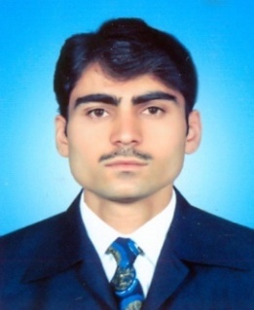
SIBGHATULALH
SIBGHATULALH.327681@2freemail.com
____________________________________________________
OBJECTIVES:
To enhance my knowledge and work devotedly in a dynamic and Innovative environment and to utilize my knowledge and strength to expand my Exposure while serving in one of the best organization to establish long term Relations with it.
____________________________________________________________________________________
ACADEMIC RECORD:
Degree | Subject | Division/ Grade | Board/ University | Year
MBA (3.5) | Finance | 3.47 CGPA | AWKUM, PAKISTAN | 2016
B.com | Account | 1st | AWKUM, PAKISTAN | 2011
D.com | Account | 1st | B.T.E Peshawar, PAK | 2009
S.S.C | Science | 1st | B.I.S.E Mardan, PAK | 2007
EXPERIENCE
- 6 months experience in S.S.Polypropylene Factory as an Accountant in Industrial Estate Hayatabad Peshawar, Pakistan.
  - 6 months experience as on job training in Pakistan Railways Accounts & HR dptt, Pak.
  - 2years and 4 months experience as an Account Officer in Mushtaq Particle Board Risalpur Industrial Estate Bara Banda, Pakistan.
Computer and Accounting Skills:
- Quick Book
- Peachtree
- Tally
- Microsoft Office
- Data entry
ACHIEVEMENTS:
- First position holder in Debate competition organized by URDO (United Rural Development Organization) Peshawar.
RESEARCH TOPIC:
My research topic in MBA
“COMPARATIVE STUDY OF MANAGEMENT OF WORKNG CAPITAL ON THE PROFITABILITY OF SUGAR AND TEXTILE INDUSTRY OF PAKISTAN”.

