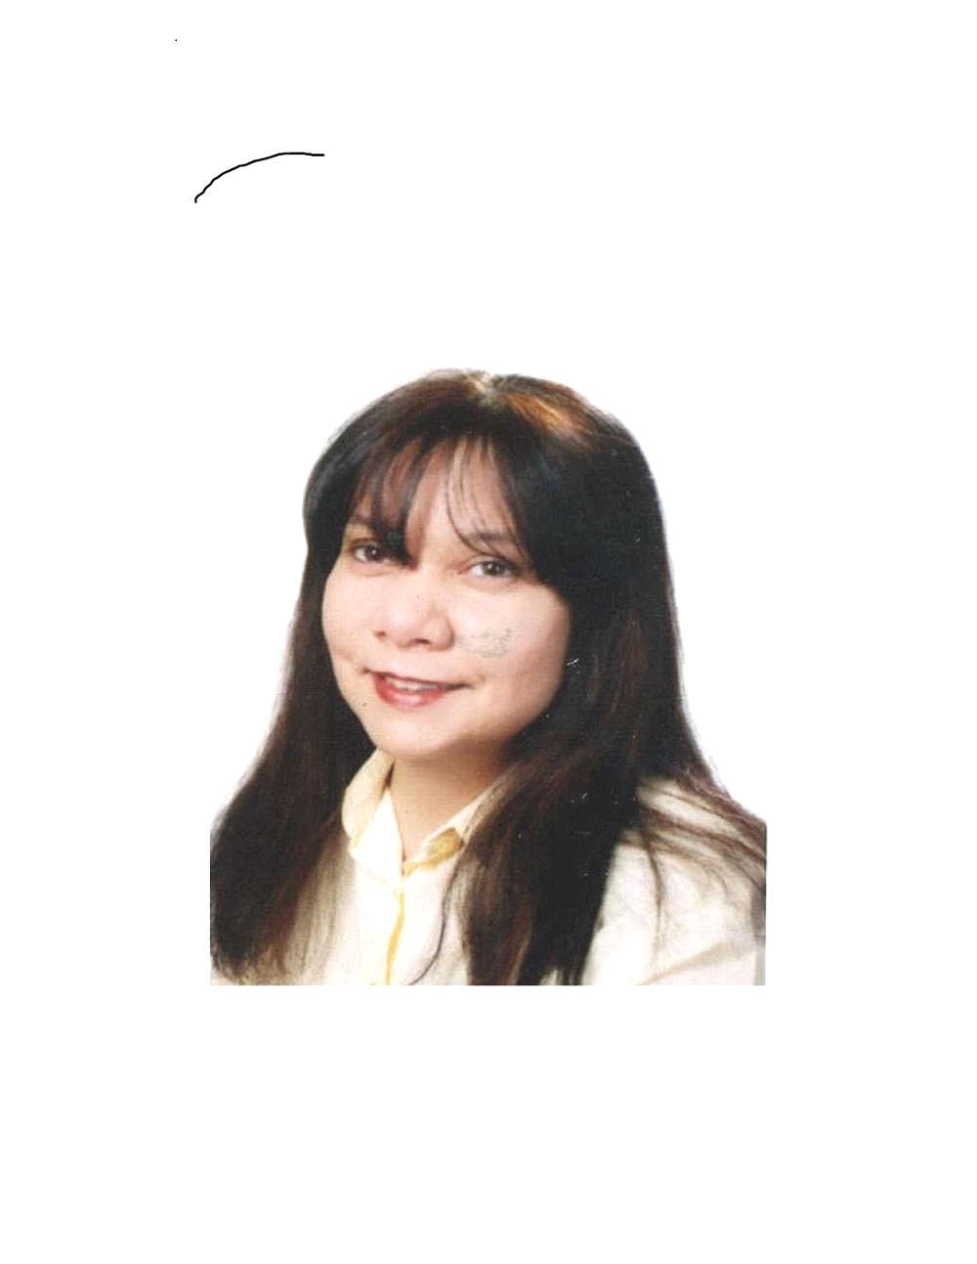
Eman Al Masri-English/ESL Teacher
Email address - eman.327741@2freemail.com
Mobile no: C/o 0502360357 Current Residence: Egypt

PROFESSIONAL PROFILE
- Teacher of English & English As A Foreign Language with over 10 years experience in Egypt, Istanbul and Abu Dhabi
- Trainer and Mentor
- Versatile in teaching methodology for children ,young adults and corporate learners
- BA - Major in Journalism, Minor in Sociology

PROFESSIONAL EXPERIENCE

Full-Time ESL Teacher, Berlitz Language Centers known as New York Studio of Languages at present, Istanbul, Turkey
December 2011- December 2014
- Taught all levels General English and Business English ( Beginner to Advanced)
- Assessed students’ levels via tests, task-based approaches and CALL exercises.
- Taught groups and private students at the center and company premises
- Used CALL( computer assisted language learning) in the lesson and online to assist in the teaching and learning process
- Trained students to do the IELTS
- Taught English to children ages 6-8 in summer school

Part-Time English Instructor, Oxford English Academy, Cairo, Egypt, November 2010 –June 2011
- Taught Intermediate corporate learners General English at company site
- Used New Headway textbooks for ESL learners-Intermediate level
- Taught private learners- one on one
- Assessed learners’ progress
- Worked on improving the four skills: reading , speaking, listening & writing

Part-Time English Instructor, Direct English Language Center, Cairo, Egypt, February 2010 -June 2010
- Taught Beginner, elementary and Intermediate levels General English
- Assessed English level at the beginning and end of course
- Taught Groups and private learners
- Used Direct English Curriculum
- Taught English conversation classes at the intermediate level

English As A Second Language Trainer, Centre For British Teachers, Abu Dhabi, UAE, Dec 2008 - July 2009
- Taught the admin staff at a secondary school ESL from beginner to advanced levels under the supervision of the Abu Dhabi Education Council (ADEC) in order to prepare them for the IELTS tests and to improve their levels of fluency.
- Monitored /Observed & Assessed progress of teaching staff’s level of English usage inside the classroom
- Provided assistance and guidance in how to answer IELTS tests
- Participated in development workshop to improve school’s pedagogy
- Compiled curriculum for different levels
- Assisted in purchasing convenient ESL teaching text books for the ESL library
- Planned the ESL schedule for school staff
- Created a bilingual environment (English to Arabic)by placing suitable signage around the school to aid in the teaching and learning process
- Maintained assessment records to track progress when required using MS Word & Excel
- Kept good filing system of learners work.

English Instructor, New Horizon Training Center, Cairo, Egypt,
Feb 2008 -June 2008
- Taught elementary & intermediate levels General and Business English
- Developed mid and end of level assessments
- Trained corporate employees at company sites Business English
- Used Interchange and Market leader course books with audio tool

English Instructor, Berlitz Language Centers, Istanbul, Turkey, Jan - June 2006
- Taught 450 hrs of Conversation & Business English to all levels
- Monitored & Assessed progress through the level
- Assessed and placed learners at the convenient level
- Taught adults
- Substituted when required

English High School teacher (Grade 10&11) Kenana American College, Cairo, Egypt, Aug 2005 - Jan 2006
- Taught ESL English of up to 24 lessons /week
- Prepared daily as well as weekly plans
- Monitored progress via quizzes and exams
- Assisted& Prepared students in the SAT exams in the writing section

Part-Time English Instructor, Berlitz Language Centers, Cairo, Egypt, 2000 - 2005
- Taught 2700 hrs of Conversation & Business English to learners at the center and at company sites
- Taught adults and children using Berlitz curriculum and methodology
- Was successful in maintaining learners to progress in levels
- Maintained learners’ satisfaction by keeping a good percentage of re-enrollement.
- Monitored & Assessed progress through the level
- Substituted when required
- Developed & adopted teaching methodology at training workshops

English Facilitator/Instructor, Knowlogy International Language Centers, Cairo, Egypt, June1998 - Jan 2000
- Instructed and facilitated 1900 hrs of various General English courses using multi-media technology to learners ages 16 -50
- Taught English conversation classes at the intermediate level to corporate staff and university students
- Participated in curriculum writing project for beginner levels
- Maintained assessment records using MS Word & Excel

Voluntary English Teacher, St Andrews church, Cairo, Egypt,
Oct 1997 - April1998
- Successfully taught refugees from Southern Sudan, Eritrea and Somalia at beginner levels English of ages 15-40.
- Collected supplementary material to include in the teaching and learning process
- Attended teacher training workshops to improve teaching techniques
- Developed assessment records ( exams- exercises) for learners

Professional Certificates/Development
- Foundation Courses in English to Arabic translation, The American University in Cairo.

Education
- Bachelors of Art in Journalism & Mass Communication, American University in Cairo, Egypt –June 1994
- Post Graduate Certificate in Teaching English As A Foreign Language-University of California, Santa Cruz, April 2001-Courses studied:Assessment& Placement, Methodology, Language Structure,Learning Styles & Practicum.
- High school- Cairo American College-Egypt- A co-educational American medium accredited school-1988
- Junior & primary years- New English School- Kuwait- A co-educational British medium accredited school- 1975-1985

Personal Information
Years of experience in teaching ESL:12 Approximately
Skills:Good user of Smart technology- Microsoft Office &Fluent in English and Arabic
Citizenship: Jordanian

