Keisha
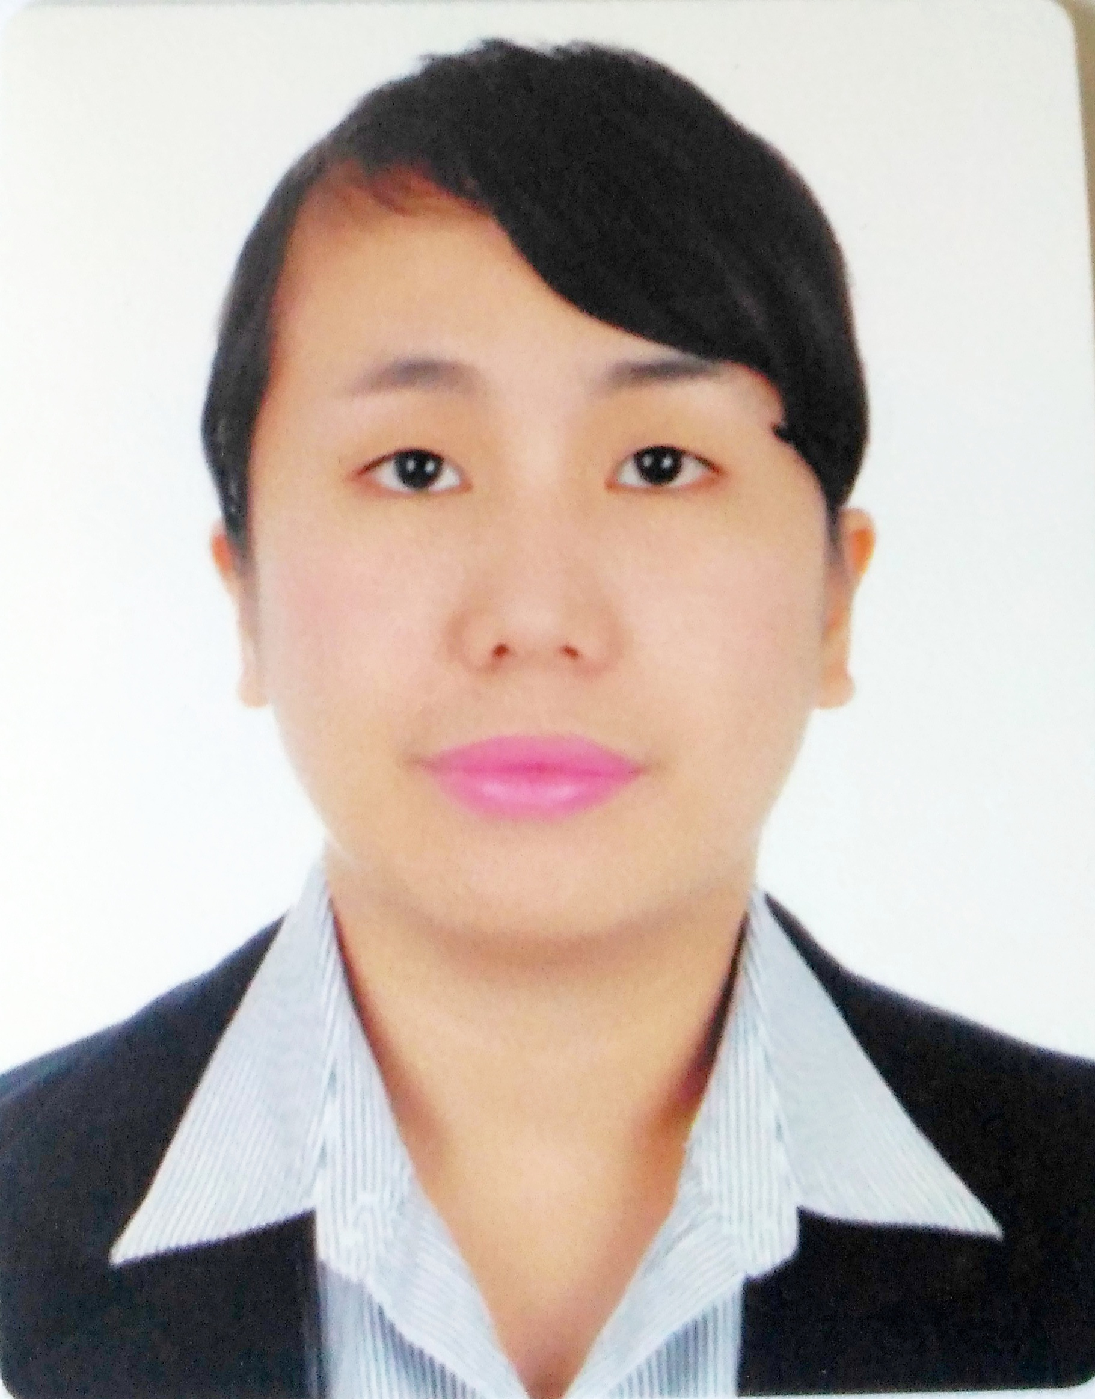
C/o-Contact #: +971503718643
Keisha.327798@2freemail.com

OBJECTIVE
Interested in a dietician position that will allow me to offer others the benefit from my expertise & experience, and to expand my experience in nutrition .
QUALIFICATION SUMMARY

- Extensive knowledge in supervising activities of department providing quantity food services, counselling individuals, and conducting nutritional research.
- Knowledge of principles, methods, and procedures for diagnosis, treatment, and rehabilitation of physical and mental dysfunction, and career counselling and guidance.
- Experience in the principles and methods for curriculum and training design, teaching and instruction for individuals and groups, and the measurement of training effects.

WORK EXPERIENCE:

On the Job Training:

Practicum Training (200 Hours)
Kitchen Department
Hotel Del Rio Iloilo City
January 25, 2012 – February 13, 2012

Part –Time Job:

REGISTERED NUTRITIONIST-DIETITIAN
Abbot Company, Iloilo City
December 1-30, 2012

REGISTERED NUTRITIONIST-DIETITIAN
Nestle Company (Agnitio Ventures Incorporated)
February 1 - June 9, 2013

- Provides free nutrition counselling, assesses the client’s nutritional status to provide a sound nutrition care plan by Anthropometric assessment, target weight setting, nutritional risk assessment, review and analyze lifestyle disease risk and Nutrition education through health diet and lifestyle.

STAFF-DIETITIAN/NUTRITIONIST
St. Therese MTCC Hospital, San Agustin St., Iloilo City
January 21, 2014-August 15,2014

- Menu Planning
- Request for food quantities needed in production based on daily census
- Supervises tray line and food distribution
- Ensures food standardization and provide cycle menus
- Checks diet list for changes in diet orders
- Conduct nutrition counselling for client/patient’s that needs nutrition care plans such as Diabetic, Renal, Weight management & etc.
-Translate the science of nutrition into everyday information about food.
- Calculate patients’ nutritional requirements using standard equations based on assessments of blood chemistry, temperature, stress, mobility and other relevant factors.
- Practice HACCP procedures
- Ensure s food safety

HEAD DIETITIAN/NUTRITIONIST (Pioneer)
QualiMed General Hospital, Atria Park, Don Pison,San Rafael Mandurrio,
Iloilo City
September 1,2014 - PRESENT

- Menu Planning
- Request for food quantities needed in production based on daily census
- Supervises tray line and food distribution
- Checks diet list for changes in diet orders
- Making policies and procedures to the Department such a duties and responsibilities of each everyone, the time scheduled for the meals and the process flow of food service system
- Monitor and maintain the cleanliness of the department by proper supervising and monitoring
- Doing more in paper works such as weekly and monthly report about the meal census of patients, doctors and snacks requested by some department such as IVT Department and special events in the hospital. And, also making action plans to the department such as Midyear and year round plan.
- Conduct nutrition counselling for client/patient’s that needs nutrition care plans such as Diabetic, Renal, Weight management & etc.
-Translate the science of nutrition into everyday information about food.
- Calculate patients’ nutritional requirements using standard equations based on
Assessments of blood chemistry, temperature, stress, mobility and other relevant factors .
- Supervising the preparation and serving of meals.
- Collecting patient data for surveys, analyzing it and producing reports.

AREAS OF EXPERTISE
- Nutrition Clinic
- Nutritional issues
- Health Promotion
- Nutritional Calculations
- Menu Analysis
- Developing Nutritional Care Plans
- Nutrition Screenings

EDUCATIONAL BACKGROUND

TERTIARY:

Bachelor of Science in Nutrition and Dietetics’
University of San Agustin
General Luna St. Iloilo City
2008-2012

SECONDARY:
University of Iloilo
Mapa St. Iloilo City
2005-2008

PRIMARY:
ApolinarioMabini Elementary School
General Luna St. Iloilo City
1999-2005

PERSONAL DATA:
Date of Birth: May 2,1992
Age: 24years old
Height: 5’2”
Weight: 54kgs
Nationality: Filipino
Civil Status: Single
Eligibility: Registered Nutritionist Dietitian
Date Taken: July 24-25, 2012
Date Released: July 27, 2012

Key Skills and Competencies:
- Computer Literate
- Experienced in Hospital settings
- Microsoft Proficient
- Concentration
- Prioritisation

AFFILIATIONS/SEMINARS/TRAININGS

- Certificate of Recognition
Secretary Officer
HRM/ND/CA DEPARTMENT
“ for his/her commitment to responsible leadership and invaluable service for the University of San Agustin”
February 24th, 2011

- Nutrition Dietitian’s Association of the Philippines
“A Sustainable Healthy Lifestyle Advocacy: A Challenge to the Nutritionist-Dietitians”
Sarabia Manor Convention Center
February 9, 2009

- H2010:SYMPOSIUM on HYDRATION
Westown Hotel, Iloilo City
October 7,2010

- Osteoporosis Society of the Philippines Foundation
Sarabia Manor Hotel and Convention Center,Iloilo City, Philippines
May 2010

- Nutrition Dietitian’s Association of the Philippines
“Advancing Nutrition and Dietetics Practice :GoGlocal”
Fiesta Pavilion , Manila Hotel, Manila, Philippines
February 19, 2014

- Nutrition Dietitian’s Association of the Philippines
“Integrating and Innovating Nutrition & Dietetics in Sustainable Development”
Royal Garden Convention Center, Gen. Luna St., Iloilo City,Philippines
February 15, 2016

I hereby certify that the above information is true and correct up to the best of my knowledge and belief.

