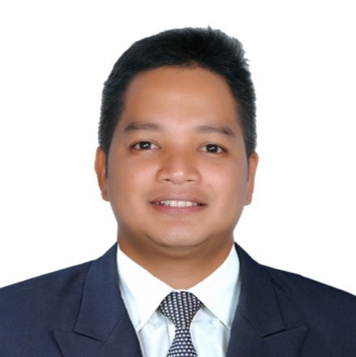
MATHEWS
MATHEWS.327848@2freemail.com

CAREER OBJECTIVE
To secure a position in a company that will utilize my strengths in financial and interpersonal skills that offers me a variety of challenges and opportunities.

PERSONAL DATA
Date of Birth : February 9, 1982
Age : 34 years old
Place of Birth : Polillo, Quezon
Civil Status : Married
Nationality : Filipino
Religion: Roman Catholic
Height : 5’3 ft.
Weight : 59 kgs

SKILLS
- Highly skilled in dealing with financial and numeric data.
- Excellent work habits including a willingness to work extra hours if necessary to get the job done, especially when important deadlines cause greater than normal departmental pressures.
- Proficient in general office duties, including Microsoft Word, Microsoft Excel and Power Point as well.
- Ability to communicate, both orally and in writing.
- Highly motivated individual and fast learner.
- Proficient in using accounting software such as Great Plains version 9,Property Manager,Oracle and SAP same thing application withPeachTree,Navision,ERP and Quick Books as well, they are all using SQL language.

WORK EXPERIENCES

INVENTORY CONTROLLER ASSISTANT
FOREVER LIVING PRODUCTS FZE
Dubai Airport Free Zone Authority Blk 23-24
Currently working and was joined to the Company last April 13, 2016

- Prepares monthly product reconciliation for all the Branches here in UAE and in Saudi.
- Check all the product items if we have sufficient stocks for the whole month to be distributed to all branches of our Company.
- Monitor all the fast moving product in quarterly basis.
- Monitor in and out of the product in the warehouse.
- Prepares monthly inventory of all the stocks.
- Prepares Delivery Receipt to be delivered for the Branches of Forever Living Product Inc.
- Prepares Gross Receipt Notes for monitoring purposes of all the stocks.

INVENTORY CONTROLLER
SOMNO MED.PHILIPPINES
Pasong Tamo,Makati City
August 2015 – November 2015

- Prepares monthly consumption for all major and minor materials used by the operation.
- Releases everyday materials used by the operation department.
- Monitor all the production that produced by the operation people.
- Monitor all the materials both major and minor to know if the stock materials is enough for the production.
- Prepares monthly inventory both for major and minor materials.

ACCOUNTS RECEIVABLE & PAYABLE SPECIALIST
CASHIER
C.F.SHARP HOLDINGS, INC.
Intramuros, Manila
June 2008 – December 2014

- Prepares invoices and send out to subsidiary.
- Monitor and follow-up on receivables that have been outstanding for unusually long periods of time.
- Reconciles bank and investment accounts, and prepares related journal entries.
- Prepares payments and request reimbursement.
- Prepares financial statements related to accounts receivable and bills payable.
- Process accounts payable paperwork at completion of the check run.
- Releases checks to various supplier/vendor.
- Provides BIR2307 form for the amount withheld.
- Manage accounts receivables and payables.
- Monitors and prepares cashier’s daily transactions.
- Manage petty cash and replenish after the day of the transactions.
- Deposits checks/cash to the Bank.
- Prepares issuance of official receipt.
- Perform other accounting, financial, or administrative tasks as may be required from time to time by my Superior.

ACCOUNTS RECEIVABLE SPECIALIST
TAHANANG YAMAN HOMES CORP. (Real Estate Industry)
Mandaluyong City
March 2007 up to June 2008

- Monitors cashier’s daily collection.
- Reconciles bank and prepares related journal entries.
- Prepares financial statement.
- Monitors past due accounts.
- Monitors client’s ledger.
- Prepares creditable withholding tax for those accounts that are already loaned and released to the client and to be submitted to Bureau of Internal Revenue.

ACCOUNTING ASSISTANT
EARTH AND STYLE CORPORATION (Real Estate Industry)
Ortigas, Pasig City
June 2006 up to February 2007

- Deposits checks/cash to the Bank.
- Prepares monthly sales report.
- Prepares and update Buyer’s/ client’s ledger.
- Reconciles accounts, and prepares related journal entries.
- Performs other duties that may assign by my Superior.

BOOKKEEPER
CPA’ES & CO.
Baguio City, Philippines
July 2004 up to February 2006

- Manage payroll and related items.
- Reconciles bank accounts, and prepares related journal entries.
- Prepares Monthly sales report.
- Prepares Income Statement.
- Prepares Monthly creditable withholding tax, expanded and VAT to be submitted to Bureau of Internal Revenue.
- Performs other duties that may assign by my Superior.

EDUCATION ATTAINMENT

Bachelor of Science in Commerce - Major in Financial and Managerial Accounting
San Sebastian College Recoletos
Claro M. Recto Ave., Manila
1999-2004

SEMINARS ATTENDED

- Customer Service and Complaints Management June 13, 2008
ECCI Training Services
Intramuros, Manila

- Introducton to 5’s October 15, 2008
ECCI Training Services
Intramuros, Manila

- Employee Motivation and Empowerment October 22, 2008
ECCI Training Services
Intramuros, Manila
- Stress Management November 13, 2008
ECCI Training Services
Intramuros, Manila

- Building Confidence and Team Culture November 20, 2008
ECCI Training Services
Intramuros, Manila

I hereby certify to the authenticity and accuracy of the information stated to the best of my knowledge.

