Azizillo
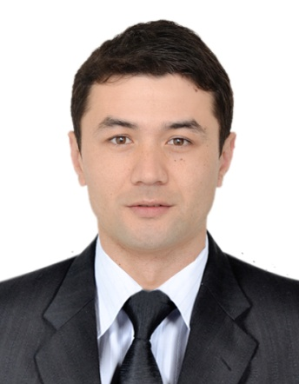
PERSONAL DETAILS

Full name Azizillo

Birth date 27/02/1988

Nationality Kyrgyzstan

E-mail azizillo.327991@2freemail.com

SUMMARY

Strong team-player, skills developed through work in customer service. A creative and motivated person with the will to succeed, well-developed communication and teamwork skills. Also the ability to work efficiently as an individual. Reinforcing and expanding skills, knowledge and career development step by step constantly.

WORK EXPERIENCE
Sales Assistant
“GUESS” - Retail store, Kwangju, South Korea 2016 Feb – 2016 Dec
- Providing excellent shopping environment to customers and generating maximum business results
- Assist customers during the sales process after the sale finish to follow up for new inquires
- Developing and sustaining friendly relationships with customers
- Wishing customers on their birthdays and anniversary through SMS and emails
- Guiding and recommending clothes to customers matching with their personality
- Keeping store organized and clean and monitoring changing rooms
- Follow up with grooming standards of the company as per company policy.
- Taking cash and credit card payments and entering them in register
Sales Assistant
“ZARA” - Retail Store, Kwangju, South Korea 2013 Dec – 2016 Feb
- Greeting & welcoming all potential and existing customers to the store.
- Matching the customer’s needs to the right product.
- Willing to approach customers and able to close a sale.
- Working as part of the sales team providing excellent customer service.
- Dealing with and resolving customer complaints and concerns.
- Having team meeting and sharing best practice ideas with colleagues.
- Analyzing sales statistics and determining sales potential & inventory requirements.

EDUCATION
Diploma of Primary School
- Russian High-school education 1994-2005
Bachelor’s degree
- Kyrgyz-Slavic Russian University 2005-2009

KEY Skills AND COMPETENCIES
- Teamwork: Resourceful team player who excels at building trusting relationships with customers and colleagues
- Computer literacy: Extensive user of MS Word, Excel, PowerPoint, Outlook, Photo Shop and etc.
- Leadership: Goal-driven leader who maintains a productive climate and confidently motivates, mobilizes, and coaches employees to meet high performance standards.
- Problem-solving: Innovative problem-solver who can generate workable solutions and resolve complaints
- Planning/organizing: Results-driven achiever with exemplary planning and organizational skills, along with a high degree of detail orientation.
- Interpersonal: Proven relationship-builder with unsurpassed interpersonal skills.

Languages
Native language: Uzbek, Kyrgyz
 | Listening | Reading | Writing | Speaking
English | Fluent | Fluent | Fluent | Fluent
Russian | Fluent | Fluent | Fluent | Fluent
Korean | Fluent | Fluent | Fluent | Fluent
Turkish | Good | Good | Good | Good

OTHERS
Interests
Swimming, aerobics, soccer, national wrestling and reading books

