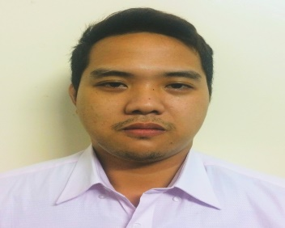
Mervin
Mervin.328399@2freemail.com

Objective:
Seeking a suitable position in a reputed Organization, where my education and experience can contribute to the enrichment of myself and growth of the organization.
Job History

SALES REPRESENTATIVE
One Active Enterprises
Bacoor Cavite, Philippines
August 2015-July 2016

Responsibilities:
- Excellent communication skills, verbal and written
- Excellent knowledge of the market conditions to aid sales
- Good contacts for creating sales
- Complete knowledge of the product and service
- Should be able to multitask as they have to manage a number of people
- Should have the ability to meet targets
- Should be on the constant lookout of sales prospects
- Have the ability to work even at odd hours
- Follow up on each sale
WAITER
Aling Tonyas Restaurant
Macapagal blvd, Pasay,Philippines
February 2015 to July 2015

Responsibilities:

- Escort customers to their tables
- Prepare and set tables following standard practice
- Present menus to guests and respond to questions concerning menu items, then offer recommendation when asked to
- Find out if customers are enjoying their meals or if they are having issues, resolve any complaint quickly
- Explain to customers or guests how the different menu items are made, describing the various ingredients and the cooking methods
- Serve food, wine, and other beverages to guests clear tables or counters of dishes and glasses and take them for cleaning at the kitchen

ADMIN/SECRETARY/DOCUMENT CONTROL/DATA ENCODER
NEHEMIAH ONE VENTURES INC.
Bacoor Cavite, Philippines
July 2014 to December 2014

Responsibilities:

- Check the information quality of documents, ensuring that these are properly registered in the system
- Perform self-audit of administration details of the Report before endorsing it to the assigned auditor
- Assist in amending Reports based on review done by the Trade Analyst, as necessary
- Provide suggestions on process improvements
- Report the correct information to the company
SALES MERCHANDISER
Wilcon Depot
General Mariano Alvarez, Cavite, Philippines
November 2013 to May 2014

Responsibilities:
- Plan and develop merchandising strategies that balance customers’ expectation and company’s objective
- Analyze sales figures, customers reactions and market trends to anticipate product needs and plan product ranges/stock
- Collaborate with buyers, suppliers distributors and analysts to negotiate prices, quantities and time-scales
- Remain up to date with industry’s best practices.
Education:

- ASSOCIATE COMPUTER TECHNOLOGY (2012)
National College Science Technology

Languages Known:
English Fluent, Tagalog

Personal Information:

Date of Birth: November 24,1992
Nationality: Filipino
Marital Status: Single
Gender : Male
Visa Status: Tourist Visa

