MUHAMMAD
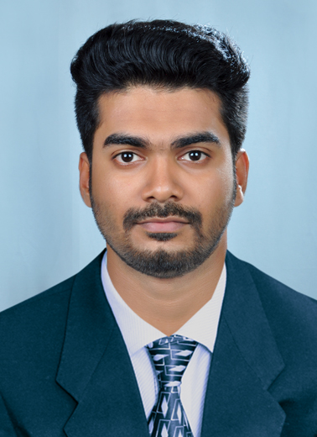
MUHAMMAD.328426@2freemail.com

OBJECTIVE
To start and build a career in mechanical engineering with leading corporate of hi-tech environment with committed and dedicated people, which will help me to explore myself fully and realize my potential.

ACADAMIC QUALIFICATION
- Completed Bachelor of Mechanical Engineering, from Mangalam college of engineering, Kerala, India , Mahatma Gandhi University, May2016.
- Completed 11th and 12th from P.K.K.S.M.H.S.S , Kerala, India, March 2011
- Completed 10th from Holy Mary central school Kerala, India, March 2009

SKILLS/STRENGTH
- Basic skill in Solid edge ,Auto CAD
- Basic skill in C++ programming
- Skills in MS office , Photoshop
- Self-motivated , excellent communication
- Can accept responsibility
- Ability to work in a team

ACADEMIC PROJECTS
- Project on “TRICIVATOR”
About Project
The ordinary excavator is meant for heavy purposes. It is not affordable for lighter purposes. It also cannot excavate in narrow places. So an excavating machine is necessary which can be used for lighter purposes at low cost, tricivator is such a device .It is basically an excavating machine which consist of three wheels. These three wheels are intended for more stability. It works pneumatically by using double acting pneumatic jacks and a dc compressor. The arm is fixed at the back of the three wheeled motor cycle. The dc compressor is driven by a 12V battery. It is expected that the tricivator will excavate a maximum of 100kg.

- Seminar on topic “NEXT GENERATION HIGH PERFORMANCE CUTTING BY USE OF CARBONDIOXIDE AS CRYOGENICS”

EXTRA CURICULAR ACTIVITIES
- Participated in project expo conducted by RIT college of engineering Kerala, India
- Perform as a team coordinator for many working models in college festivals
- Won several prize for athletics at school levels
Activities includes
- Cricket, volleyball, football

PERSONAL DETAILS
Gender : Male
Nationality : Indian
Date Of Birth : 17/04/1993
Visa Type : VISIT(Valid till 04/03/2017)
Language Known : English, Malayalam

*Further details will be provided upon request

