CURRICULUM VITAE
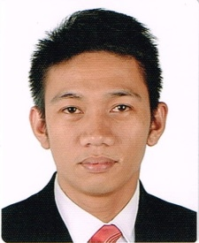
JERREMY

Email Address: jerremy.328440@2freemail.com
Birth Date: June 04, 1988
Status: Married

CAREER OBJECTIVE

To pursue a highly rewarding career, seeking for a challenging job and healthy work environment where I can utilize my skills and knowledge efficiently for organizational growth.
WORK EXPERIENCE

DISPATCHER (SALES)
Arayat Concrete Sand Inc.
Brgy, Manuali, Porac, Pampanga, Philippines
September 29, 2008 – December 21, 2016

Summary
In charged in releasing finished product to be delivered to sister companies and other commercial clients.
- Receives daily schedule/requirements of sister companies and other clients.
- Encodes finished product dispatched in preparation of daily reports.
- Monitors plant operational hour for plant operational rate.
- In charged in releasing delivery receipt using filing system.
- Report sales and truck load dispatched to marketing personnel.
- Supervised plant operation in absence of plant supervisor.
- Handles cash.
- Assist/entertain walk in clients.
EDUCATIONAL ATTAINMENT

APRIL 2008 Information Technology
Major in Computer Programming
CLSU-Computer Training Center Foundation
Science City of Munoz, Philippines
SKILLS

- Computer Literate (excellent in MS Excel, MS Word, MS PowerPoint, Programming, Internet)
- Can work in multi-tasking environment
- Great technical skills
- Problem solving and good decision making
- Negotiate and persuasive
- Works confidently within a group
- Flexible and initiative

