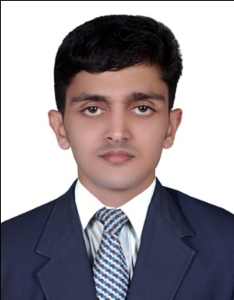
CURRICULUM VITAE

SALIM
UX / UI / WEB DESIGNER
4 Year Experience
E-mail: salim.328501@2freemail.com

CAREER OBJECTIVE
Looking for a long association with people oriented organization where individual skills, talent, honest and hard working are acknowledged and a better work environment is provided. I can use my managerial skills and abilities that offer professional growth. UX / UI / web designer / Front-end developer / Web host managing, I have 4 years and 1 months of experience.

WORKING EXPERIENCE
- UX DESIGNER: ( 13-Jun-2016 to till now ) DLI SYSTEMS, DLI IT PARK CHELEMBRA CALICUT KERALA INDIA
- UI DESIGNER: 1 Year and 3 Months ( 02-March-2015 to 13-May-2016) PIXOTRI TECHNOLOGIES, CHERTHALA INFOPARK KERALA INDIA
- UI DESIGNER: 1 Year ( 15-March-2014 to 27-feb-2015 ) VICTOGEN SOFTWARE TECHNOLOGIES,
Palakkad KERALA INDIA
- WEB DEVELOPER: 1 Year and 6 Months (25-Jun-2012 to 31-Dec-2013) NECTOSOFT, Ernakulum KERALA INDIA.

TECHNICAL QUALIFICATION

- PHP Diploma in Web Programming – (Specialization in PHP).
- PGDMA (Post Graduate Diploma in Multimedia & Animation).

PERSONAL & PROFESSIONAL STRENGTH & SKILLS
- Good Networking Ability, Process strong,
- Very energetic, organized, focused and creative.
- Quick learning ability, analytical and critical abilities.
- Proficient in Adobe Photoshop CS6, Dreamweaver CS6.
- Knowledge in Adobe Illustrator CS6, J Query Advanced animations, HTML 5, JavaScript, Bootstrap,
- PHP, PHP Graphics, MySql-5, Ajax, InDesign, Director, MS Office, ISM Malayalam, Swish max.
LINGUISTICS ABILITIES
English, Malayalam

ACCADEMIC QUALIFICATION
Year Board/University
2009-2011 B.com University of Calicut
2006-2008 Higher Secondary, Board of Examination, Kerala
2006 S.S.L.C ,Board of Examination, Kerala

PERSONAL INFORMATION
Marital Status : Single
Date of Birth : 15-Jun-1990
Nationality : India

DECLARATION

I hereby accept that all the information provided above is true up to my knowledge.

