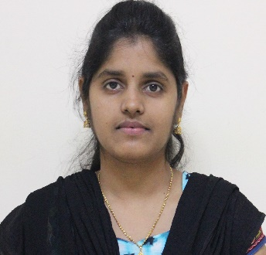
CURRICULUM VITAE

Vanitha
Vanitha.328522@2freemail.com

CAREER OBJECTIVE
To help the organization to attain its organizational goals thereby to enhance my career prospects and seeking a position to utilize my skills and abilities in the Industry that offers professional growth while being Resourceful, Innovative and Flexible.

COMPETENCIES
- Proficient in MS office and Internet.
- Acquired knowledge in Database[SQL], DB visualize and Testing.
- Basic knowledge in HTML, Macro and Unix Command.
- Having very good experience in working as agile environment.
- Quick learner and capable of working independently.
- Ability to communicate professionally and effectively with client.
- Exceptional ability to prioritize multiple daily tasks to ensure work is completed with minimal supervision.
- Ability to prioritize time effectively and work well under pressure.
- Good communication skills, both written and verbal.

Technical Skills:
- MS Office
- Putty
- DB Visualizer

PROFESSIONAL BACKGROUND
- SENIOR PROCESS EXECUTIVE - DATABASE TECHNICIAN (19th Jun 2013 onwards)
TATA CONSULTANCY SERVICES LTD.
CHENNAI, INDIA
www.tcs.com
Domain: Market Research

Job Profile :

- Generating reports on sales data every week and comparing it with the competitor data.
- Interacting with the onshore team and providing the required data
- Creating standardized documents and updating it on daily basis.
- Attend the KT session and prepared documents.
- Tackle issues as they occur and find out the root cause from my end with the process knowledge.
- Represent the team in meetings and conference calls with Clusters.
- Taking Meeting notes in weekly basis and share to the team.
- Co-coordinating between different departments for any issue amongst verticals.

- PROCESS ASSOCIATE - CHARGE ANALYST- (02nd May 2012- 31st May 2013)
AGS HEALTH PVT.LTD.
CHENNI, INDIA.
www.agshealth.com
Domain: US Healthcare

Job Profile
- Reviewing and validating the clinical information of patients like prescription, Health policy and other related documents.
- Acts as an intermediate person between the Payer and the Provider in posting the claims for processing.
- Validating the Patient details with the registered details in the Payer’s list.
- Coding the Insurance Code and sending it to the next level for payment processing.
- Provides notes to the payer on enquiries related to claims processing like rejections, denials, and missed claims.
EDUCATIONAL BACKGROUND
- Master Degree in Computer Application (MCA) - (2014):
Madras University, Chennai - India
- Bachelor Degree in Computer Application (BCA) - (2011):
Prof. Dhanapalan college, Madras University, Chennai - India
PERSONAL DETAILS
Date of Birth : 05 Nov,1990
Sex/marital status : F/Single
Languages known : English, Tamil
Nationality : Indian
Visa status : Visit Visa
Current Location : Al Karama, Dubai.

Declaration
I hereby declare that all the above details are true and correct to the best of my knowledge

Date:

