RESUME
Geethu
Geethu.328942@2freemail.com 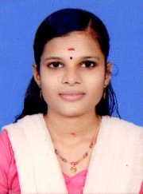

Career Objective

To gain an expertise in the field of Accounts and administration and contribute to the growth of organization learning by implementing and learning would be the hallmark of my career.highly focused and meticulous accountant with an excellent employment record of accuracy and client satisfaction. able to work well independentlyor as part of a financial management team.

Key Skills

- Good communication and leadership skill
- Sincere and hard working
- Computerized accounting with tally
- Internet and Ecommerce management
- Management accounting and income tax

IT Skills

-Diploma In Computerized Financial Accounting from IGNET( INDIRA GANDHI NATIONAL EDUCATION TRUST )
-Tally ERP- 9

Education

Qualification | Year | Institution
MBA (HRM & FINANCE) | 2015 | Prathibha College
Bcom(cooperation) | 2012 | Prathibha College
Plus Two | 2009 | G H S S Chalissery
SSLC | 2007 | G H S S Mookkuthala

Language Skill

Language | Read | Write | Speak
Malayalam | Yes | Yes | Yes
English | Yes | Yes | Yes
Hindi | Yes | Yes | Yes

Work Experience

- Accountant - Favourite Readymade Garments Company, Malappuram from August 2015 to August 2016

Personal Information

Date of birth :17/06/1992
Gender :Female
Marital status : Married
Nationality : Indian

Declaration
I do here by declare that the above given details are and accurate to the best of my knowledge.

