NARAYAN
Email- narayan.328990@2freemail.com 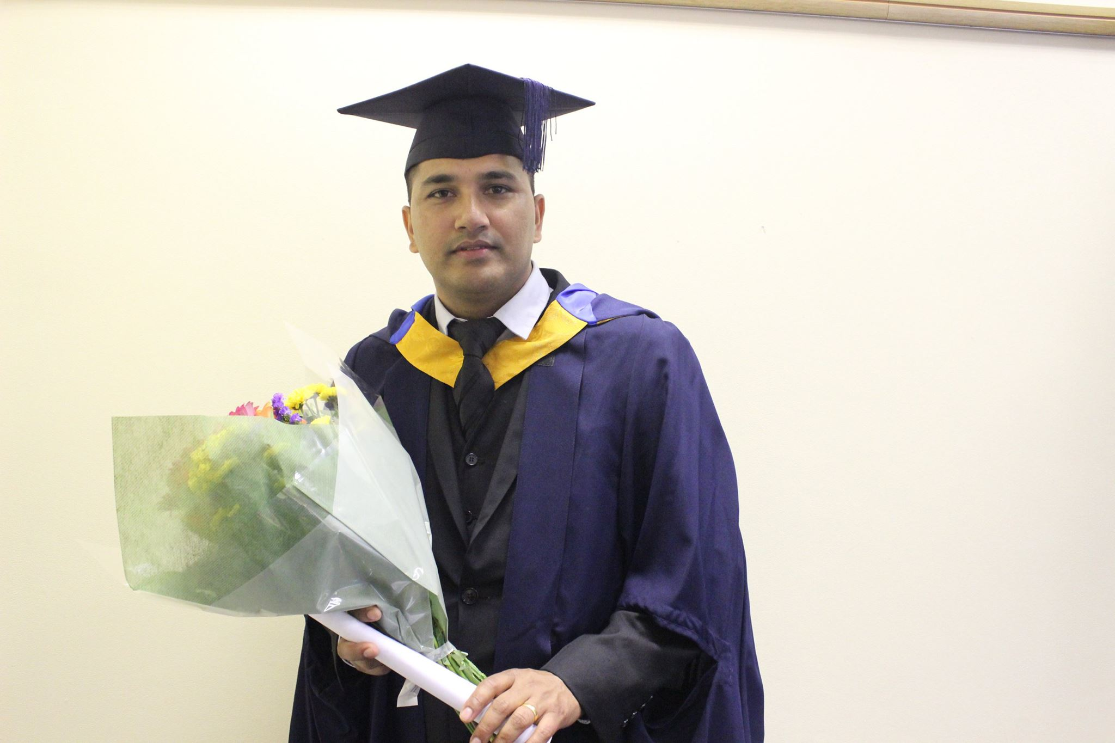
SUMMARY
A self-motivated, confident and friendly individual who enjoys working within a team setting or alone using own initiative, Possesses valuable experience from in-group laboratory experiments associated in university and working within Retail, Customer service. Enthusiastic about learning new skills and gaining further work experience, Trustworthy, punctual and committed to delivering quality customer service. Performs well under pressure and has a proven ability to work in a neat and tidy manner, whilst maintaining quality of service. Now seeking an opportunity in an organization where existing skills can be utilised and developed upon further to their fullest extent.

EDUCATION

MASTER OF BUSINESS ADMINISTRATION: MBA 2015
Anglia Ruskin University UK
Business Administration

DIPLOMA: BUSINESS MANAGEMENT 2013
Business Management Graduate Integrated:
The Association of Business Executives UK

BACHELOR: Humanities and social science 2008
Tribhuvan University, Nepal

PCL: Humanities and social science 2005
Tribhuvan University, Nepal

EXPERIENCE

TESCO STORE LTD UK: DEPFORD
London, UK
ASSISTANT MANAGER 07/2014 to 11/2015

TERIYAKI YA! THE JAPANESE AND KOREAN RESTAURENT: GREENWICH
London, UK
INTERNSHIPS: Marketing, Public Relation (PR) And Human Resource (HR) Coordinator-FROM UNIVERSITY 02/2014 to 07/2014

TESCO STORE LTD UK: DEPFORD
London, UK
SUPERVISOR 07/2012 to 07/2014

SAINSBURY STORE LTD UK: STARTFORD CENTRE
London, UK
TRAINEE TEAM LEADER 12/2011 to 05/2012

CUSTOMER ASSISTANT 02/2011 to 12/2011

DUTIES AND RESPONSIBILITIES
ASSISTANT MANAGER
- I lead my team, making decisions every day that supports my colleagues to do their jobs and puts a smile on their faces as they deliver a great Shopping Trip for customers.
- I ensure I have the right people in the right place at the right time.
- I lead a team, making decisions every day that support them to do their jobs.
- I plan all seasonal, trade driving and promotional activities to achieve maximum sales, impact, and presentation and manage service to customers.
- I coach my team to maintain good store standards both in the warehouse and on the store floor.
- I ensure the correct security and product protection procedures are followed for high value stock.
- I am responsible for all safe and legal routines for my store, ensuring plans are in place to address identified issues
- I work 'shoulder to shoulder' with my team to coach them on what good looks like
- I make sure my team are trained and give them confidence in their capabilities and pride in their achievements
- I care about people and treat everyone with respect.

SUPERVISOR
- I supports team manager and performs management duties when manager is absent or out of office
- I manages inventories and stock, including keeping detailed records of inventory use and sales, and advising management on ordering where necessary
- I provides encouragement to team members, including communicating team goals and identifying areas for new training or skill checks
- I generates and shares comprehensive and detailed reports about team performance, mission-related objectives, and deadlines
- I ensures company brand materials and physical working spaces meet and exceed company presentation standards
- I provides quality customer service, including interacting with customers, answering customer enquiries, and effectively handling customer complaints.

CUSTOMER ASSISTANT
- Greeting customers who enter the shop.
- Being responsible for processing cash and card payments.
- Stocking shelves with merchandise.
- Giving advice and guidance on product selection to customers.
- Keeping the store tidy and clean.
- Attaching price tags to merchandise on the shop floor.
- Receiving and storing the delivery of large amounts of stock.
- Keeping up to date with special promotions and putting up displays.

INTERESTS
In my spare time I enjoy a range of activities including listening to music and watching movies. I also enjoy regularly surfing the Internet for research and leisure purposes. In addition, I like reading novels and newspapers and like to keep up to date with current affairs.

HIGHLIGHTS
- Excellent interpersonal and communication skills, with a proven ability to converse with all levels of the public
- Highly organised and reliable with excellent time management skills
- Proven ability to work under pressure and meet deadlines within strict timescales
- Self-motivated graduate with well-developed project management and IT skills combined with a flexible attitude to work.
- A critical thinker with strong analytical skills.
- Strong team-player skills developed through work in retail, in-group laboratory experiments associated with the degree, and in particular group presentation work, in which good marks were achieved.
- Have good presentation skills combining sound analytical research and clear verbal explanation.
- Seek out new responsibilities irrespective of reward and recognition.
- Sound understanding and awareness of Health & Safety.

- Management and Leadership training - UK
- Level -2 food and Hygiene training - UK
- Health and safety and Fire training - UK

SKILLS
- Analytical skills
- Business plan
- Interpersonal and communication
- Inventory
- Leadership
- Legal compliance, people management
- Presentation skills
- Projectmanagement
- Self- motivation, team player, time management.

REFERENCES
References available upon request

