Curriculum Vitae 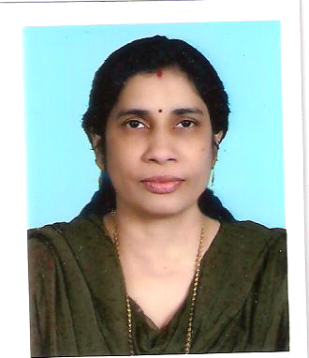

PRASANNA
PRASANNA.329009@2freemail.com

PERSONAL DETAILS

Nationality : Indian
Date of Birth : 11th May, 1965
Marital Status : Married
Languages Known : English, Hindi, Tamil and Malayalam
Visa Status : Employment Visa
Holding a Valid UAE driving Licence

QUALIFICATION :
Academic
- S.S.L.C.
- K.G.T.E. Typewriting Lower and Higher.

Professional
- Conversant with Windows Word, Excel.
- Proficiency in Typing.

OBJECTIVE

- A mentally challenging and intellectually satisfying position with career advancement possibilities.

CAREER

I started my career from BOMBAY, the No.1 business city of INDIA, and gained good experience from various companies. The work experience from the establishments in UNITED ARAB EMIRATES lead into the career best portfolios and working environments also an asset to my profession which gave me full confidence in promoting my profile for supporting staff to give any entities positive results. My experience with some of the organizations is given hereunder.

EXPERIENCE : TOTAL 9 YEARS
Since November, 2007, I am working with HH Property Management, Abu Dhabi, U.A.E., as Secretary and Sales Support.
Job Functions :
- Co-ordination under Sales & Finance.
- Co-ordination for Administration

1 Year : from June, 2006 to July, 2007.
One Year I worked with Marine Light Real Estate, Abu Dhabi, U.A.E., as Secretary.

2 Years : from 2004 to 2006
These two years I worked with Super Markets in Abu Dhabi, U.A.E., as Cashier.

2 Years
I worked 2 YEARS with various organizations in Bombay, India, as Typist,
Secretary, Data Entry Operator and Administrative Assistant.

MY STRENGTHS :
- Result Oriented, Well Organized, responsible, dedicated and sincere in work.
- Good communication, public relations and interpersonal skills.
- Possess a high level of integrity
Visa Transfer/NOC available.

