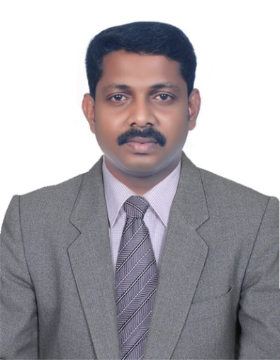  BIJITH  BIJITH.329026@2freemail.com  Personal Data:  Date of Birth:  10-05-1980  Languages: English,Hindi,  Malayalam &Tamil  Russian (as business  language) | Career Objective  A challenging position in the field of where I can demonstrate my capabilities by earnest performance  Asset:  - Quick learner and easy adaptation skills with any working atmosphere and trouble shooting  - Self-disciplined in professional and personal life  - Self-motivated and enthusiasts  - Ability to work under pressure  Educational qualification  - Bachelor of Commerce (B.com. Management information systems, Economics and Accounting with Co Operation) from University of Calicut, Kerala, India.  - Pre Degree (Commerce) from University of Calicut, Kerala, India.  - S.S.L.C Board of Public Examinations, Kerala  Summary of Computer Experience:  - Diploma in Practical Accounting & Computerized Financial Accounting (Tally, Daceasy, Peachtree &Ex next generation)  - MS Office, and other fundamentals.  - Working experience in jewellery accounting software Sun business network management system.  - Working experience in jewellery accounting software Visual Ace Gold.  Professional experience:  From April 2013 To June 2016:  Elan jewels, Dubai,UAE:  This a reputed Hong kong based wholesale jewellery dealing with18k gold & diamond jewellery.  As an Accountant:  - Passing necessary journal entries for material transfer and vouch the bills and other documents related to the purchasing and transfer of materials and make payment to the suppliers as per the terms and condition  - Co-operating with auditing work, by giving detailed information about any doubt or query.  - Bank reconciliation, coordinating inter branch transaction  - Passing manufacturing entries regarding metal, diamond &precious stone used.  - Preparing detailed branch wise sales report by management requirement.  - Finalization of accounts.
From September 2009 To October 2012:
Barakat Gold Jewellery LLC, Dubai.
This is a reputed jewellery group in Dubai it’s having branches in Australia, which dealing with 18K gold and diamond jewellery as well as various kinds of precious and semiprecious stones.

As an Accountant:
- Passing necessary journal entries for material transfer and vouch the bills and other documents related to the purchasing and transfer of materials and make payment to the suppliers as per the terms and condition
- Co-operating with auditing work, by giving detailed information about any doubt or query.
- Bank reconciliation, coordinating inter branch transaction
- Passing manufacturing entries regarding metal, diamond &precious stone used
- Preparing detailed branch wise sales report by management requirement.
- Finalization of accounts.
- Controlling branch wise stock taking and giving report to the management regarding shortage and excess of items

From December 2003 To Jan 2009:
Jagjivan Ranchhod Goldsmith LLc, Dubai.
This is a reputed jewellery shop in Dubai, which is dealing with large collection of 18k gold and diamond jewellery.
As sales executive:
- Establish and maintain excellent working relationship with customers and procure their needs.
- Responsible for arrangement of jewellery and make sure that all items are in proper order. Checking of stock and requesting of goods depending upon the stocks available in the showroom.
- Report on product movement as per brands.
- Maintain cleanliness and orderliness

From august 1999 To 2003 November:
National Radio Electronics, Kerala, India.
It is a company, which is dealing with large collection of Electronic home appliances and assembling unit.
As an accountant cum Storekeeper:
- Maintaining stock register, stock inward and stock outward register.
- Preparing sales ledger, purchase ledger and delivery details.
- Receiving materials from the factory and recording and check the supporting documents. Preparing stock register of spare parts and distribution to the repairing and maintenance unit
- Passing necessary journal entries for maintenance report and material transfer.
- Verifying purchase invoices for spare parts, petrol, diesel and other service activities for the delivery vehicle and accounting the same.
- Handling petty cash for the division and keeping track on all the eligible petty cash holders’ account and also preparing petty cash statement for proper accounting.

