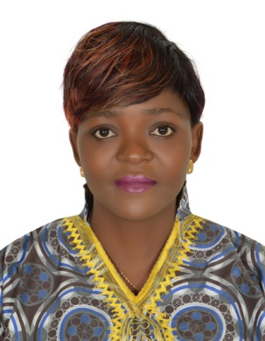
CURRICULUM VITAE

NAME : NDONG
Email : NDONG.329157@2freemail.com
SEX : FEMALE
DATE OF BIRTH : 18/MAY/1980
VISA STATUS : TOURIST VISA(3months)
NATIONALITY : CAMEROONIAN

Position: NURSE
PERSONAL SUMMARY
An experienced and fully qualified nurse with 5+ years of experience of working in a busy hospital environments in both the government and private sector. Able to work on my own initiative, or in support of other healthcare professionals, whilst ensuring that at all times patient care procedures and practices are adhered to. Looking for a challenging position where I can prove my worth, and expertise in the nursing arena, all geared towards enabling the company to attain its desired goals. HAAD in process.
CAREER HISTORY
Registered Nurse (RN) - Medicalized Health Center Nkwen/ Maternal and Child health Advocacy International - Nkwen (MCAI).
January 2011- November 2016.
- Having to communicate in a caring manner with patients and their family members.
- Carrying out administrative duties like updating and maintaining patient records in hospital wards, administering daily drug and medicine prescriptions to patients via injection or orally.
- Supervising and mentoring student and newly qualified nurses.
- Involved in the administration procedures for a patient’s admission and also their discharge.
- Making patients aware of their treatment to ensure they are fully informed and consent to their treatment.
- Educating patients on matters of hygiene.
- In charge of the PMTCT unit in the hospital
- Recruitment and Drug adherence /nutritional counseling of HIV positive mothers at first ANC, and post-natal
- Follow up of HIV exposed babies
- Ensure PCR and rapid testing of exposed babies at the appropriate ages.
- Health education in support group meetings
- Home visit of lost to follow up clients
- Monthly and quarterly reporting to the hierarchy

PROFESSIONAL EXPERIENCE
- Able to contribute in practical ways to the success of my team and to hospital targets.
- Involved in providing direct patient care, including assessing their needs and discussing their treatment and medical care with hospital doctors and consultants.
- Making sure the working environment is safe in a busy environment that is under pressure.
- To varying degrees have worked in very busy labour/delivery and post-natal clinics.
- Ability to remain calm in difficult situations whilst at the same time being observant, adaptable and firm with patients.
- Experience of creating individual patient care systems that look after a patient’s physical, mental and social need.
- Ability to respond quickly to emergencies.
- Excellent organizational skills and having the ability to prioritize urgent treatments.
- Having excellent communication skills, ability to empathize to gain a patients trust and confidence.
- Able to prioritize busy workloads.
- Experience of collecting and recording Blood Pressure, pulse, temperature, weight and respiration.
KEY COMPETENCIES AND SKILLS
- Nursing audits | - Care management | - Patient counseling | - Administrative skills
- Duty call attendance | - Ward management | - Emergency assessments | - Wound dressing
- Medication | - Communication | - Fast learner | - Conduct deliveries
EDUCATIONAL QUALIFICATIONS
2009 – 2010 : Bachelor of Technology in Nursing, National Polytechnic Bambui Cameroon
2006 – 2009 : Higher National Diploma in Nursing, National Polytechnic Bambui Cameroon
1996 – 1998 : Advanced Level GCE Cameroon
1991 – 1996 : Ordinary Level GCE Cameroon
LANGUAGE SKILLS
- English: Excellent
- French: Good
REFERENCES
Available on request

