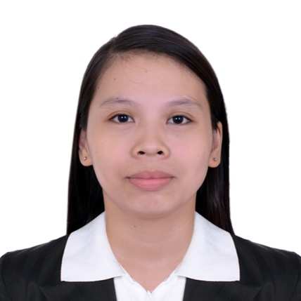
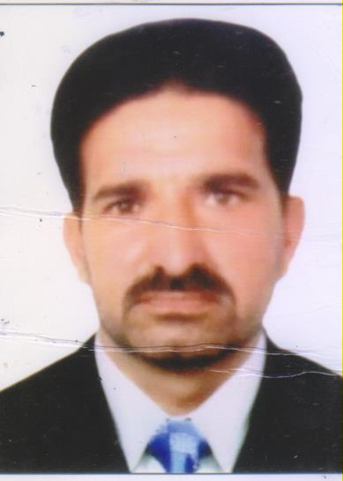

SHAKEEL
Al Satwa, Dubai, U.A.E
E-mail:
Shakeel.329245@2freemail.com

Birth Date:
15-08-1972

Marital Status:
Married

Nationality:
Pakistani

Special Skills:
Can easily adapt to environment, Detail and People Oriented, Self Sufficient and Positive, Cheerful, Versatile.
PROFILE

To seek a challenging position as a Head of Security and Administration offering responsibility, challenge, and rewarding experiences and at the same time maintaining a high standard of performance and business ethics.

Professionally qualified and highly experienced person, deep understanding and provenance administration working ability, supported by good interpersonal skills and able to work under pressure.
.

Work History:

Balad Al Aman Security Services
Security Manager
Dubai, U.A.E
2014-2015

Job Roles:
- Crime Prevention and Investigation.
- Establish and maintain procedures to reduce any internal
Theft/losses.
- Establish and maintain procedures for the escort of
Employees transporting large sums of money.
- Establish and maintain policy for employee locker control.
- Control access to critical areas where the need for access
Arises outside of normal operating hours for that area.
- Maintain control of master key inventories and ensure the
Proper whereabouts/existence of all master keys
- Must learn to personally conduct door lock readings, CCTV
surveillance equipment, etc, in order to handle sensitive
investigations.

Pakistan Army
Non Comission Officer
Pakistan
1993-2013

Educational Background:

Education/Qualification

Matriculation

Mirpur Education Board, Azad Kashmir
1990

Intermediate

Mirpur Education Board, Azad Kashmir
1992

Bachelor in Arts

University of Azad and Jammu & Kashmir, Muzaffarbad
2000

Trainings Attended:

- Security Manager (License Holder)
Dubai Police Academy
24-Oct-2015 to 29-Oct-2015

- HABC ( Health and Safety Basic Course)
First Select Security Dubai
October 2014

- Portal User Training
DPS,Bar Dubai
2015

- Instructor
Pakistan Army
2001-2008

I hereby certify that the above information are true and correct to the best of my knowledge and beliefs.

SHAKEEL
Applicant

