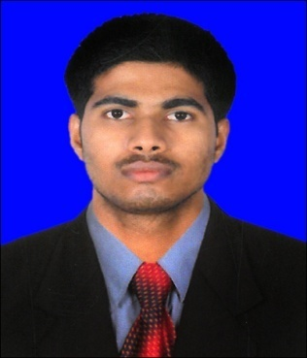
Electronic technician

Navaneeth

Email: navaneeth.329274@2freemail.com
Date of Birth: 31-01-1990

Professional Summary
Conscientious Electronic Technician with a penchant for identifying innovative ways to boost energy efficiency. Adept at maintaining installing and repairing various electronic systems and components. Committed to delivering cost-effective electronics solutions.
Core Qualifications
• Vast experience writing test cases and identifying potential efficiency upgrades
• Extensive familiarity with analog and digital systems
• Proficient in the use of monitoring and diagnostic software
• Ability to identify computer problems and determine timely solutions
• Excellent communication and assessment abilities
• Very good coordination and time management skills

WORK EXPERIENCE:
Project : AMMROC –FM
(Advanced Military Maintenance & Repairing Overhaul Center, Al-Bateen air base and Al-Dhafra Airbase, UAE)
Duration : 19-Aug-2015 to till date
Electronic Technician
19/08/2015 – Till date

Kharafi National co LLC, Abu Dhabi
Project : AMMROC –FM
(Advanced Military Maintenance & Repairing Overhaul Center, Al-Bateen air base and Al-Dhafra Airbase, UAE)
- Preventive Maintenance and Demand Maintenance Refreshment work in Electronic &
Electrical equipment Maintenance for facility.
- Performed troubleshoot on electronic systems and performed repairs.
- Tested new systems and adhered to quality control procedures.
- Prepared reports of tests and recommended system upgrades.

Electronic Technician
July2011 – August 2015
Bearys Institute of Technology, Mangalore, Karnataka.
• Prepared weekly assessments of key electronic systems to ensure efficient operations.
• Troubleshooting the problem (Hardware & Software) and servicing and maintenance of the lab instrument.
• Developed and implemented maintenance plans.
• Updated and maintained various electronic systems and circuit systems.
• Prepared reports to address identified problems or defects.
• Performed regular system checks and recorded results.

EDUCATION QUALIFICATIONS:
Diploma in Electronics and communication Engg. (Cert. attested by UAE Embassy)
Year of Passing: 2012

Department of Technical Education
Bangalore, KARNATAKA.

Industrial Training Institute - Electronics
Year of passing: 2008
St, Xavier industrial training centre, Mangalore

NCVT, Delhi

TRAINING WORKSHOP ATTENTED:
- Participated in one day technical training programmed on “Operation and Maintenance of Satellite Interactive Terminal” organized by VTU e-learning Centre, Mysore, in associated with M/s, Hughes Communications Ltd, Bangalore on 1st august 2012.
- Participated in one day training programmed on “Basic First Aid” in Aspire Middle East training institute, Abudhabi, Conducted on 2nd July 2016. Approved by Health authority and Ministry of Interior Abudhabi.

PERSONAL DETAILS:
Date of birth : 31-01-1990

Sex : Male

Religion : Hindu

Marital status : Single

Nationality : Indian

Languages Known : English, Hindi, Kannada, Malayalam and Tamil

DECLARATION:
I, Navaneeth, declare that the above information is true and correct to the best of my knowledge and nothing has been concealed or distorted.

