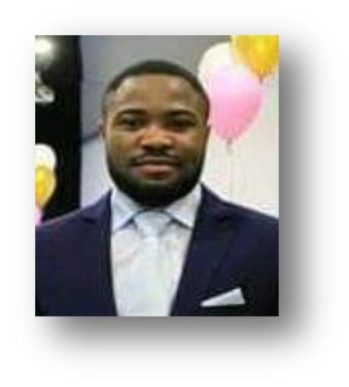
Taiwo
Taiwo.329498@2freemail.com

CAREER OBJECTIVE
Highly motivated, energetic and hardworking individual. Graduate of Environmental and health management with a solid background in environmental science, looking for a full time position to improve my career development. A passionate advocate for sustainable environmental health program, with knowledge to overseeing a wide range of environmental health measures.

CORE COMPETENCY
- Investigate complaints and compile reports about pollution control and accident at work place, and knowledgeable about food safety standard.

WORKING EXPERIENCE

Senior Sales Executive

07/11/2016 – 31/12/16 OMR Building Cleaning Services (Dubai, UAE)

• Organize sales of company’s products and services which are aimed at achieving company’s monthly and annual targets.

Internship trainee

30/05/2016 - 30/07/2016 (ICBA) International Centre for Biosaline Agriculture (Dubai,

UAE)

• Report writing; evaluate water and energy use efficiency of cucumber grown in several substrates under net house and greenhouse conditions.

Assistant General Supervisor

03/01/2008 - 28/12/2009 KOSMIC SUITE HOTELS, Lagos, Nigeria.

• Supervision of hotel equipment and overall performance of food service and kitchen operations for total satisfaction of hotel guest and effective customer service.

Assistant Manager

07/02/2010 – 27/12/2011 KOSMIC SUITE HOTELS, Lagos, Nigeria.

• Coordination of meetings to evaluate team members’ performance in relation to service delivery to guest.

Operational Manager (Per Time)

10/03/ 2009 - (MICN) Maluku Investment concept. Akure, Ondo state, Nigeria

• General supervision of facility and management of company’s asset.

EDUCATION
- 2011–2016 – BSC: Environmental Health Management, Canadian University Dubai, United Arab Emirate (Dubai, UAE)

- 2011-2012 – Professional Certificate (IT) Murdoch University International Study Centre, United Arab Emirate (Dubai, UAE).

- 2003-2009 - Secondary Education, Mahin community High School (WAEC) West Africa Examination certificate.

- 2003-2009 (NECO) National Examination certificate, High school result

PROFESSIONAL SKILLS CERTIFICATE
- 2010 - Emory University, Atlanta, Georgia U.S. ( Kingian Nonviolence Transformation Training / conflict resolution)

- 2016 - USF Health. OSHA Training Institution. ( Introduction to Occupational Safety & Health Administration)

PERSONAL INFORMATION
- Date of Birth: 1988

- Citizenship: Nigeria

- Visa status: Resident

- Gender: Male

PROFESSIONAL MEMBERSHIP
- 2011: Community Youths leader, Ode Mahin, Ondo state, Nigeria

- 2015: Clean up the UAE campaign participant organized by department of environment & health science in Canadian University of Dubai.

LANGUAGES

- English / Yoruba

