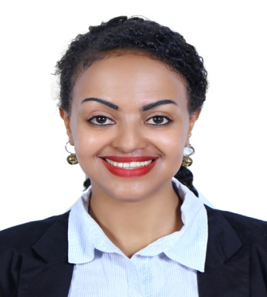

Nejat
Email: nejat.329512@2freemail.com

Personal Statement:
A highly interactive and professional sales representative with extensive experience in medical equipment sales distribution, marketing promotion and exhibition. Furnished with great competence in selling medical equipment and dental lab materials supplies to doctors, dentists, hospitals, medical schools, and retail establishments: Studied data describing new products to develop sales approach. A highly organized and efficient individual, whose thorough and precise approach to sales challenges has yielded excellent results.
With additional education and work experience as a front desk office assistant Secretary which empowered me with best communication skills and different perspective in customer care.
Objective: Looking for a suitable position in sales, Receptionist or secretary in the UAE and advance my career to the next level.
Skills:
- Excellent communication and writing skills
- Organized, flexible and personable
- Able to do all sales as well as clerical duties
- Proficient with computer such as Microsoft Word, Microsoft Excel, Power point and Internet
- Able to work under pressure
- Ability to convince customers and provide creative solutions
Work Experience
Jan 2014- Oct 2016 Siyaha Tour and Travel Agency Addis Ababa, Ethiopia
Secretary
- Presenting a professional and friendly first impression of the firm to all visitors and clients
- E-marketing and advertising.
- Updating Corporate website and Content writing
- Managing incoming phone calls and mail
- Organizing stationery orders and liaising with suppliers to meet business requests
- Replenishing and restocking the bar, always ensuring high level of stock management efficiency
- Also assumed the role of fire/health and safety officer for the entire office staff
Feb 2009 – Nov 2013 AGMAS Medical Equipment importer and supplies Pvt. Ltd. Addis Ababa, Ethiopia
Worked as sales representative
Role:
- Responsible for selling medical equipment, dental materials and other technical equipment
- Helped customer to select furniture according to their clinic
- Succeeded to increase sale in one year
- Advises customers of equipment for given need based on technical knowledge of products
- Took part in import of merchandise
- Done various other duties as assigned

Sep. 2007 – Dec. 2008 Alfarage Trading PLC Addis Ababa, Ethiopia
Worked as sales representative for cosmetics shop
- Identifying and maximizing revenue from existing customer accounts
- Submitting detailed proposals and quotations to customers.
- Providing regular and accurate sales forecast updates to Senior Managers.
- Preparing and delivering sales presentations.
- Monitoring competition and analyzing competitor activity.
- Aligning selling prices with company guidelines
Education
Diploma Secretarial Science & office Management 2005 National Collage Addis Ababa, Ethiopia
Level II certificate Secretarial Science & office Management 2004 St’Mary TVET Institute Addis Ababa Ethiopia
Diploma Dental Technician 2012 Atlas Health science collage

Personal Dossier
Date of Birth: 28 February 1987
Languages Known : English
Passport Details: EP3488228–Valid till 5/Feb 2020
Visa Status: Visit - Valid till 07 / Feb / 2017
Location Preference : UAE
Nationality : Ethiopian
~References Available upon Request

