sharanya
sharanya.329692@2freemail.com 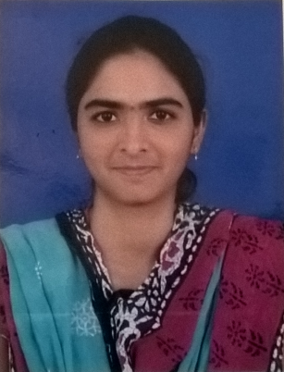

OBJECTIVE:

Quest to explore my potential and acquire skills which will help me to pursue my career with a premier organization in challenging and creative environment which gives me ample opportunities to learn and serve where the organizational goals and my career growth moves in tandem. I am dedicated and confident about adding value to the organization.

WORK EXPERIENCE : Office Administrator/HR Assistant- 1 yr 2 months

Employer: HDFC Bank, Nizamabad, India.
Duration: July 2015 to Sep 2016(1 yr 2 months)

Roles & Responsibilities:
- A team player with managerial and administrative skills that can coordinate and motivate personnel to attain company goals while maintaining high quality standards.
- A professional with excellent client relations skills, driven by new challenges. Customer & internal coordination through phone & mail.
- Worked in a busy office environment, and support office teams in order to ensure the smooth running of day-to-day activities.
- Good knowledge of posing as a first point of contact and managing the front desk. Filling applications for Account openings & closings, any new requests.
- Professional in Book keeping, Filing and thus find and obtain information and documents quickly.
- Responsible for handling the petty cash and keeping the record of expenses.
- Responsible for maintaining the records of office inventory. Checking the availability of stationary and other required things and ordering for them.

EDUCATIONAL QUALIFICATION:

- B.Tech_Bachelor of Technology in Computer Science, with 67% marks in 2015
From Jawaharlal Nehru Technological University, Hyderabad.

- Intermediate with Maths as main Subject, with 82% marks in 2011
From Board of Intermediate Education Andhrapradesh.

- SSC_Secondary school certificate, with 61% marks in 2009,
From Board of Secondary education, Andhrapradesh.

ACHIEVEMENTS:

- State level Basket Ball player, under 16 category.
- An NCC_National Cadet Corps candidate & was troupe leader for 2 years.
- Worked as CR_ Class Representative throughout my 4 yrs engineering study.
- Organized & Hosted various college festivals.

SKILL SET:
- Good Knowledge of Tally 7.2 & 9.0 ERP software, Certified in Tally 9.0 ERP
- Proficient in MS-Office (Outlook, Excel, Word), Internet savvy.
- Languages : C, C++, Java
- Database : Oracle, SQL, PL/SQL
- OS : Windows (XP, 7, 8, 10)
INTERPERSONAL SKILLS :
-Confident, time management capability.
-Can work efficiently in a group as well as an individual.
-Self motivated, hard working and goal-oriented with a high degree of flexibility, creativity and commitment.
PERSONAL INFORMATION :

Gender : Female
Marital Status : Married
Date of Birth : 23-11-1993
Languages Known : English, Hindi and Telugu
Interests : Knowing about new things & Browsing Internet
Hobbies : Playing Basketball, Badminton & listening to music
Visa : Visit Visa (valid till 23rd FEB, 2017)

