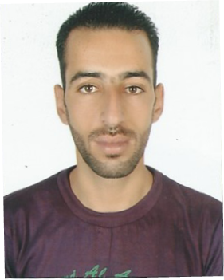 | grim
 | Al - Kolayaa
 | Sharjah, United Arab of Emirate
 | Grim.329871@2freemail.com
Personal information :
Place and date of birth : |  | 01\08\1987 Tizi-ouzou - Algeria
Gander : |  | Male
Marital Statue : |  | Married
Nationality : |  | Algerian
Religion : |  | Muslim
Driving license : |  | UAE Driving License The third category, Heavy vehicle
Education :
Intermediate school – aghandosn – tizi-ouzou – Algeria |  | 2001 - 2002
Skills :
Language :
Arabic : |  | Very good
English : |  | Good
French : |  | Excellent
Computer :
Microsoft Office : |  | Very good
Windows : |  | Excellent
Work history :
Logistic company Al – Mobasher |  | From 11\2015 until now
Logistic company Al – Ashekaa |  | From 2013 to 2015
Al Akarat company |  | From 2010 to 2013

