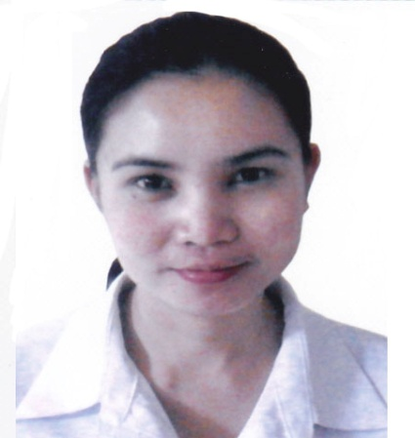
CURRICULUM VITAE

MARIVIC
Marivic.329922@2freemail.com

OBJECTIVES

- To be able to gain a meaningful experience as a professional in the various fields such as in administration and in secretarial and helping the company realize its overall objective.

- To be able to utilize my education, experience, and skills as administration in one of the country’s leading company.

WORK EXPERIENCE

Position: Project Coordinator/ Document Control/ Site Admin
Name of Company: Adyard Abu Dhabi LLC, Construction and Oil & Gas Co.
(assigned to client- Veolia Water)
Address of the Company: Liwa 1, Mussafah Industrial Area, Abu Dhabi, UAE
Year: June. 2015 to December 20, 2016
Work Specification:

Office support for projects execution in all respects which includes but not limited to;

Document Control and management as per company procedures

Project office management and administration

Coordination for resources mobilization as required for projects execution including their medical, safety trainings.

Coordination with all other departments including clients for related issues and for expediting

Collection of inputs and submission of monthly, weekly and daily progress reports as applicable

Care and custody of all projects documents and communications
- Archiving and retrieval of historical information and documents related to projects

- Support proposals for preparation and compilation of documents for technical bid submissions

Position: Secretary / Admin Assistant/Receptionist/Sales Support/Project Assistant/GM Executive Secretary
Name of Company: Bavaria International Exhibition Org.
Address of the Company: Tourist Club Area, Abu Dhabi, UAE
Year: Nov. 2013 to May 31, 2015 ( can start immediately)
Work Specification:

- Attend Telephone calls
- Responsible for all logs registry such as Incoming letters and outgoing, incoming faxes and outgoing, visitors log, list of incoming and outgoing calls, log for staff monitor report and make internal memos,
- Responsible for incoming and outgoing emails
- Welcoming visitors and greet and offer them tea, coffee or water
- Making letters to clients either by mail or written
- Making phone calls for sales and promoting the services of our company
- Responsible for the people in the office, monitoring their time in and time out.
- Making schedules for my Manager
- To support & implement the command of the Boss and monitor the performance of subordinates and coordination of the activities being carried out and to be carried out in the Department.
- Organizing, preparing agendas for, and taking minutes of meetings;
dealing with correspondence, collating information, writing reports, ensuring decisions made are communicated to the relevant people
- Assist in the implementation of activities according to the project’s annual, quarterly and monthly work plans
- Disseminate project information to all employees
- Assisting the general manager/manager in different projects like planning, costing and identifying possible market.
- Assist in the day to day activities of the company.
- Devising and maintaining office systems;
- Booking rooms and conference facilities, booking tickets and hotel reservation for my manager if he has out of the country conference or meetings
- ordering and maintaining stationery and equipment organizing and storing paperwork, documents and computer-based information
- Photocopying and printing various documents, sometimes on behalf of other colleagues

Position: Credit and Collection Staff
Name of Company: Davao Security and Investigation Agency, Inc
Address of the company: Suazo st. cor. Juan Luna, Davao City, Philippines
Year: March 2008 to September 2013
Work Specification:
- Encoding collection and posting of original receipt from subsidiary ledger of clients to its respective accounts.
- Verifying payment of clients against their respective billing.
- Validating payment with attached original receipt against daily cash collection or clients credit advice.
- Preparing aging of receivables and ensuring accounts are properly updated.
- Making follow-ups to clients for their past due accounts.

Position: Accounting Staff
Name of Company: Martinez & Associates
Address of the company: Habana Comp. Rizal st. Davao City. Philippines
Year: January 2006 - February 2008
Work Specification:

- Preparing voucher for payment.
- Performed accounts payable & coordinated monthly payroll functions
- Managed vendor accounts, generating weekly on demand checks.
- Ensured compliance with accounting deadlines.

Position: Office Staff/Secretary/Sales Representative
Name of Company: Ever safe International Enterprise, Inc
Address of the Company: Riverfront Village, Maa Davao City, Philippines
Year: February 2005-December 2005
Work Specification:

- Market and promotes products.
- Preparing for daily accomplishment report.
- Attend phone calls and preparing daily appointments of the Manager.

Position: Sales Representative
Name of Company: Crown Regency Residence (CLUB ULTIMA)
Address of the Company Cabaguio st. Davao City, Philippines
Year: July 2003 - December 2004
Work Specification:

- Doing marketing and marketing related jobs; such as promoting products to clients and making them believe that the product fits for their taste and preference.

Position: Office Staff
On the job training
Name of Company: National Housing Authority
Address of Company: Monteverde st. Davao City, Philippines
Year: November 2002 to March 2003

EDUCATIONAL BACKGROUND

Tertiary Holy Cross of Davao College, Inc. 2002-2003
Sta. Ana Ave., 8000 Davao City, Philippines
Bachelor of Science in Commerce
Major in Management Accounting

Secondary Pablo Lorenzo National High School 1998-1999
Mandug, Davao City, Philippines.

Elementary T. AwadEchevarria Elementary School 1994-1995
Mandug, Davao City, Philippines

CORE COMPETENCIES

- Computer literate
- Proficient in Microsoft Applications such as Word, Excel
- Proficient in English written and oral communication
- Competent in organizing and coordination work
- Can work with minimum supervision
- Can work under pressure
- Ability to organize and manage

I HEREBY CERTIFY THAT THE ABOVE INFORMATION ARE TRUE AND CORRECT TO THE BEST OF
MY KNOWLEDGE.

